# Amazon Lightsail

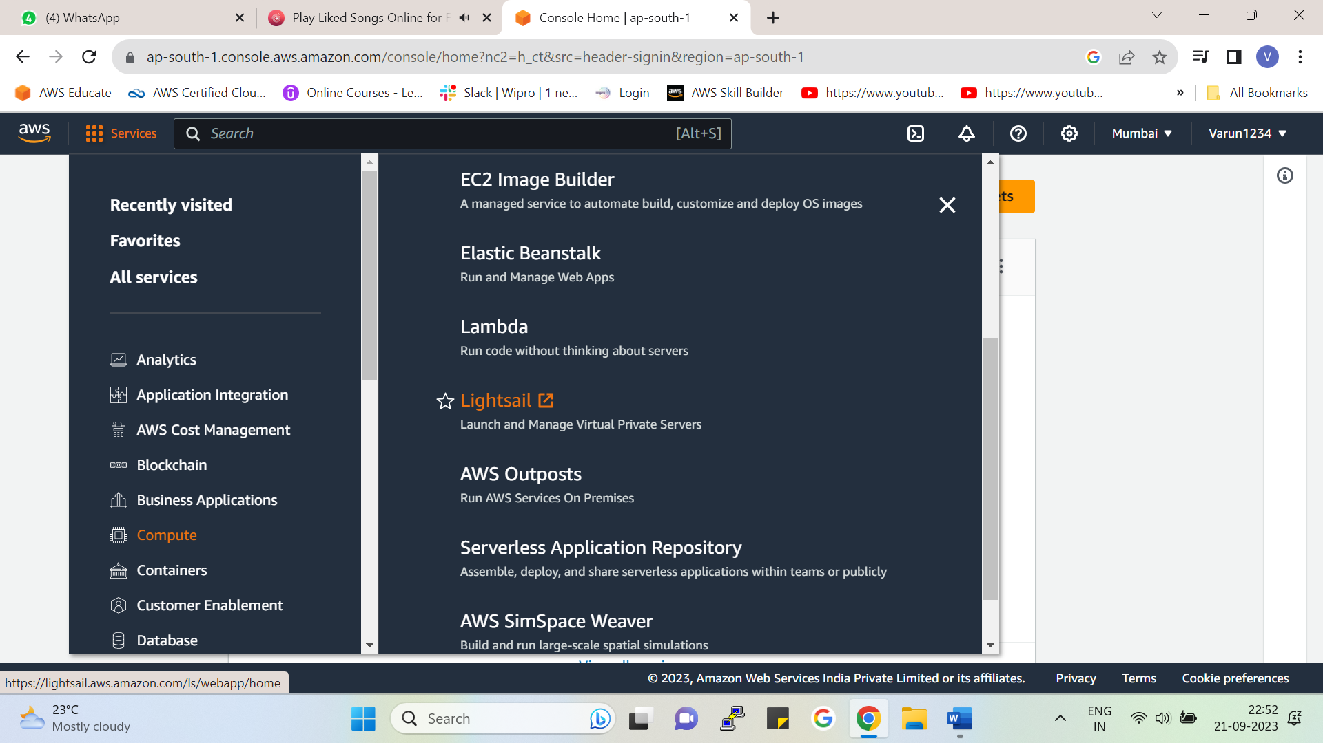



Amazon Lightsail is a computing service.

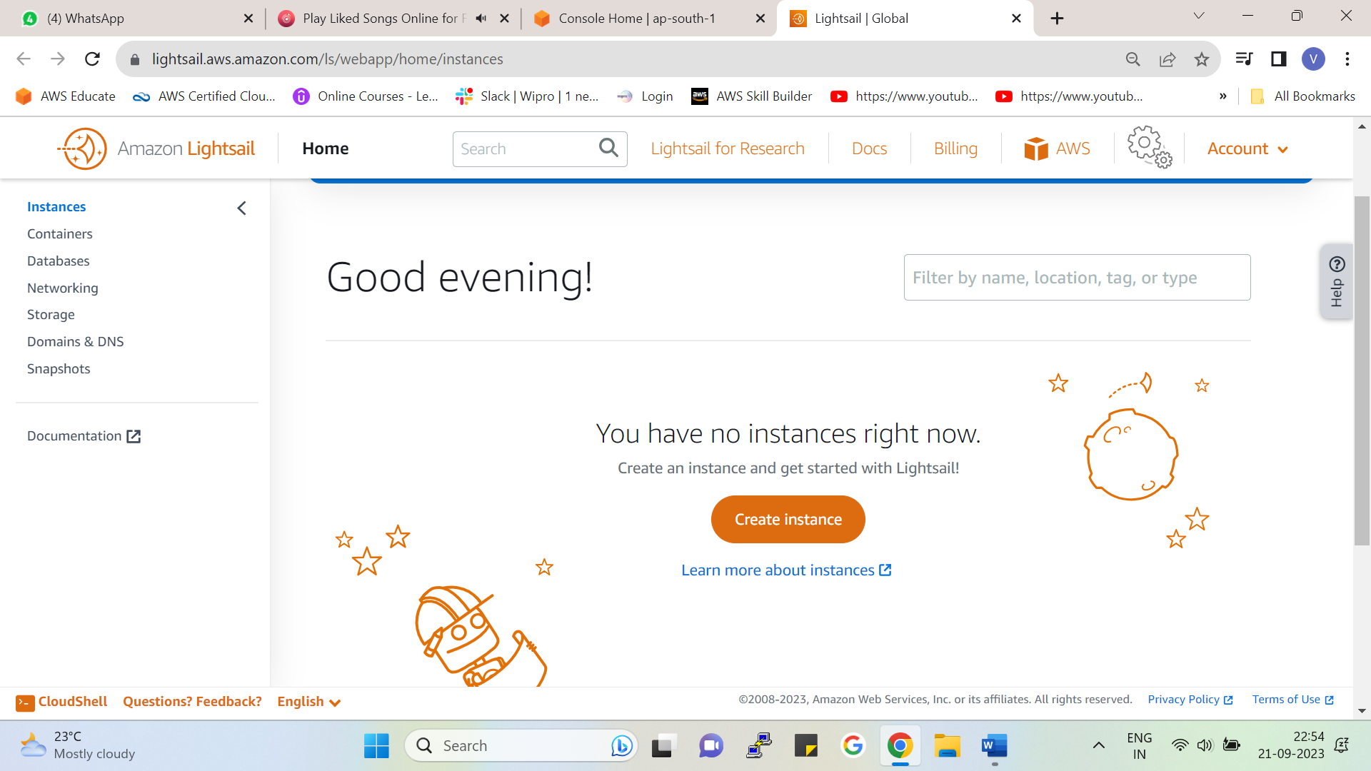Click on Create instance

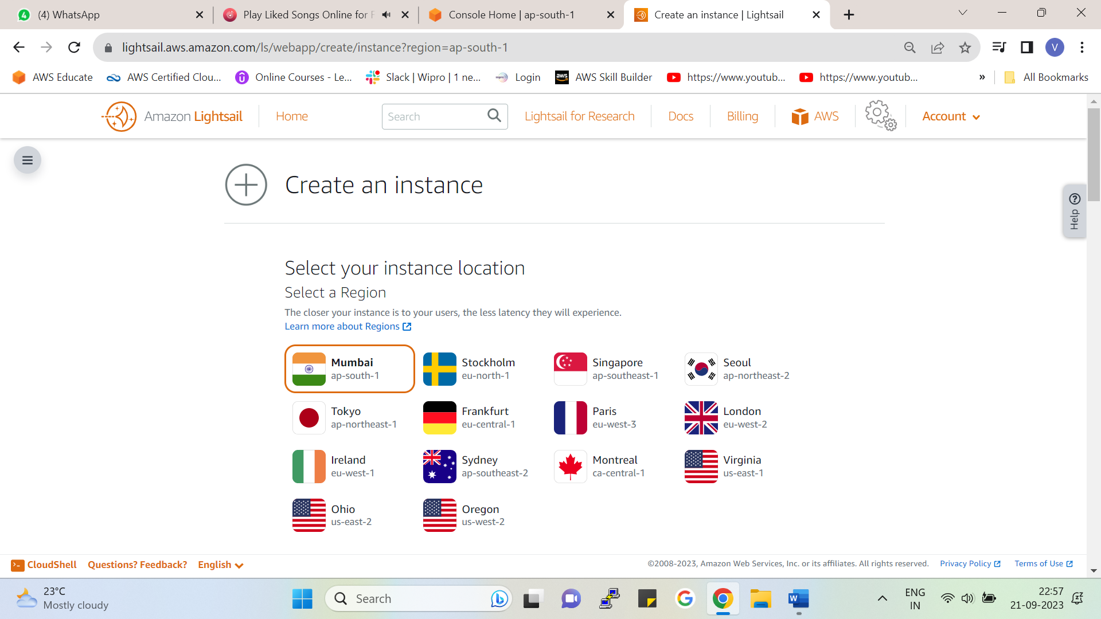

Select the region in which you want your instance here I have selected ap-south-1 in the Mumbai region.

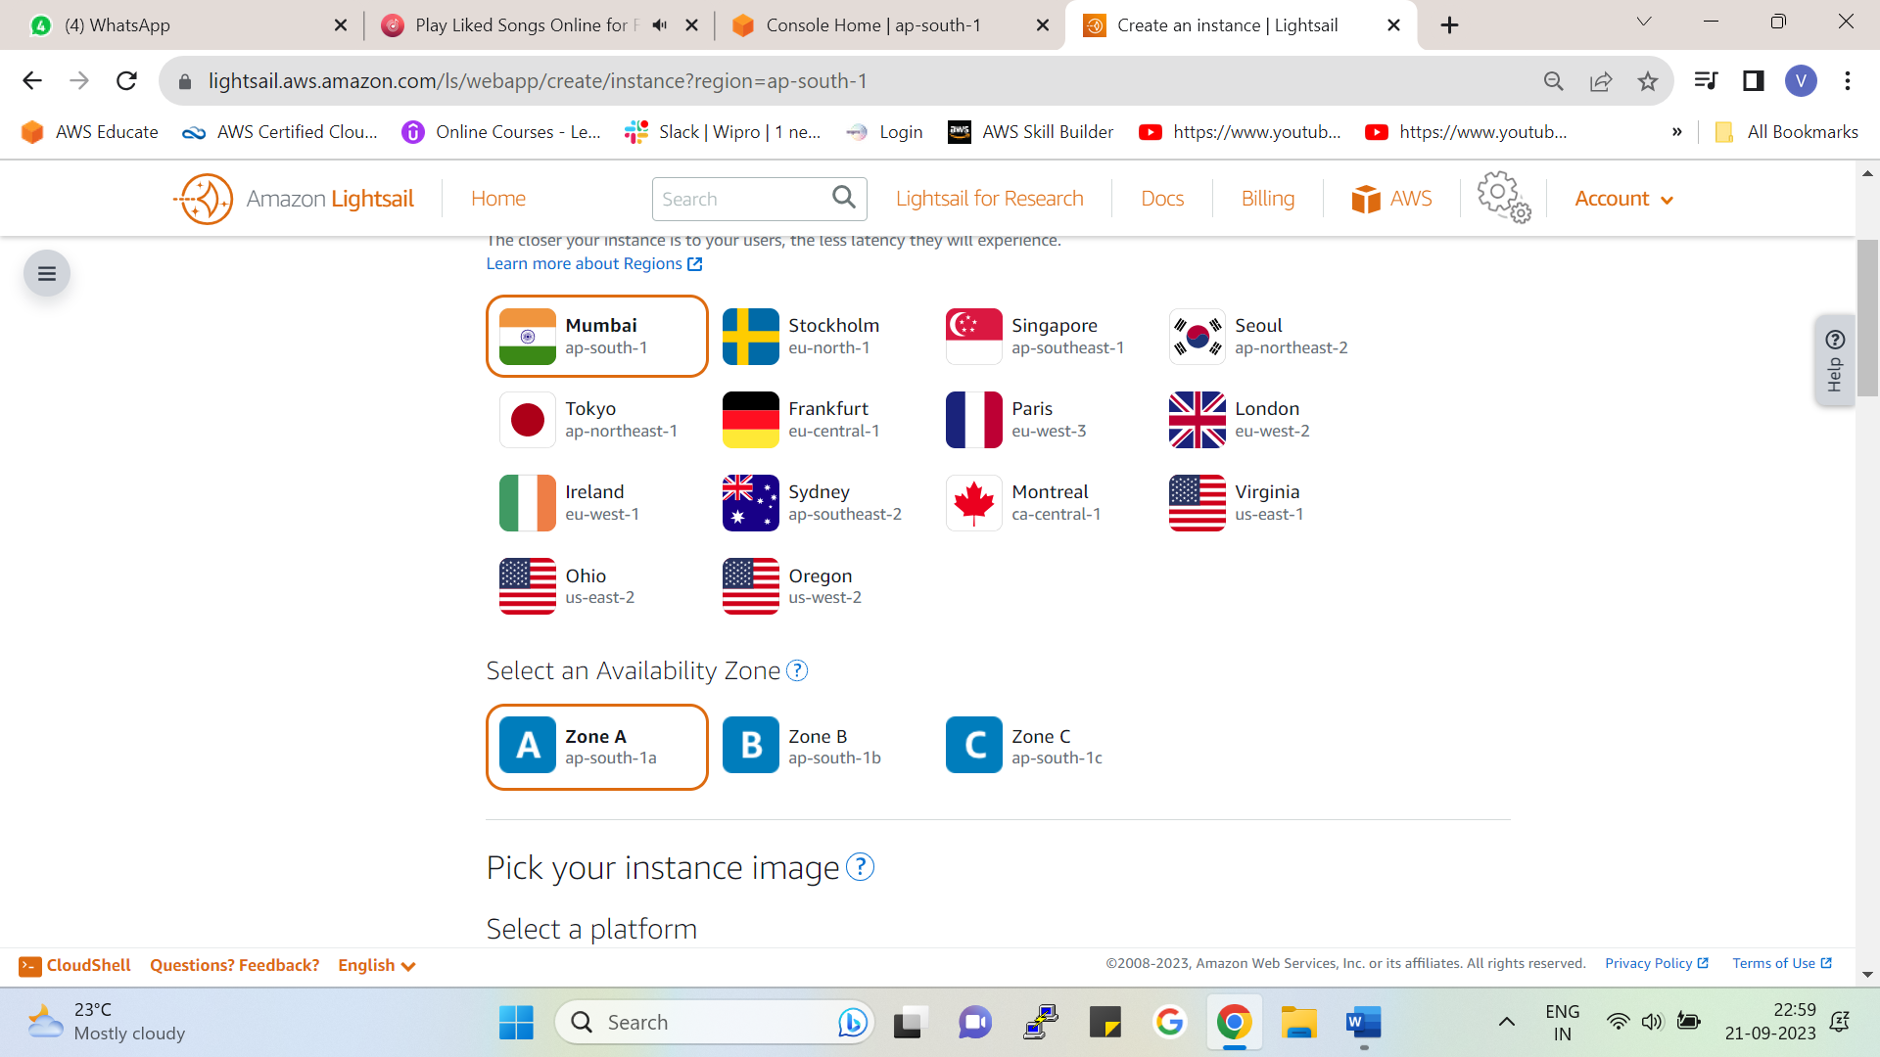

You can also select the availability zone as (1a,1b or 1c)

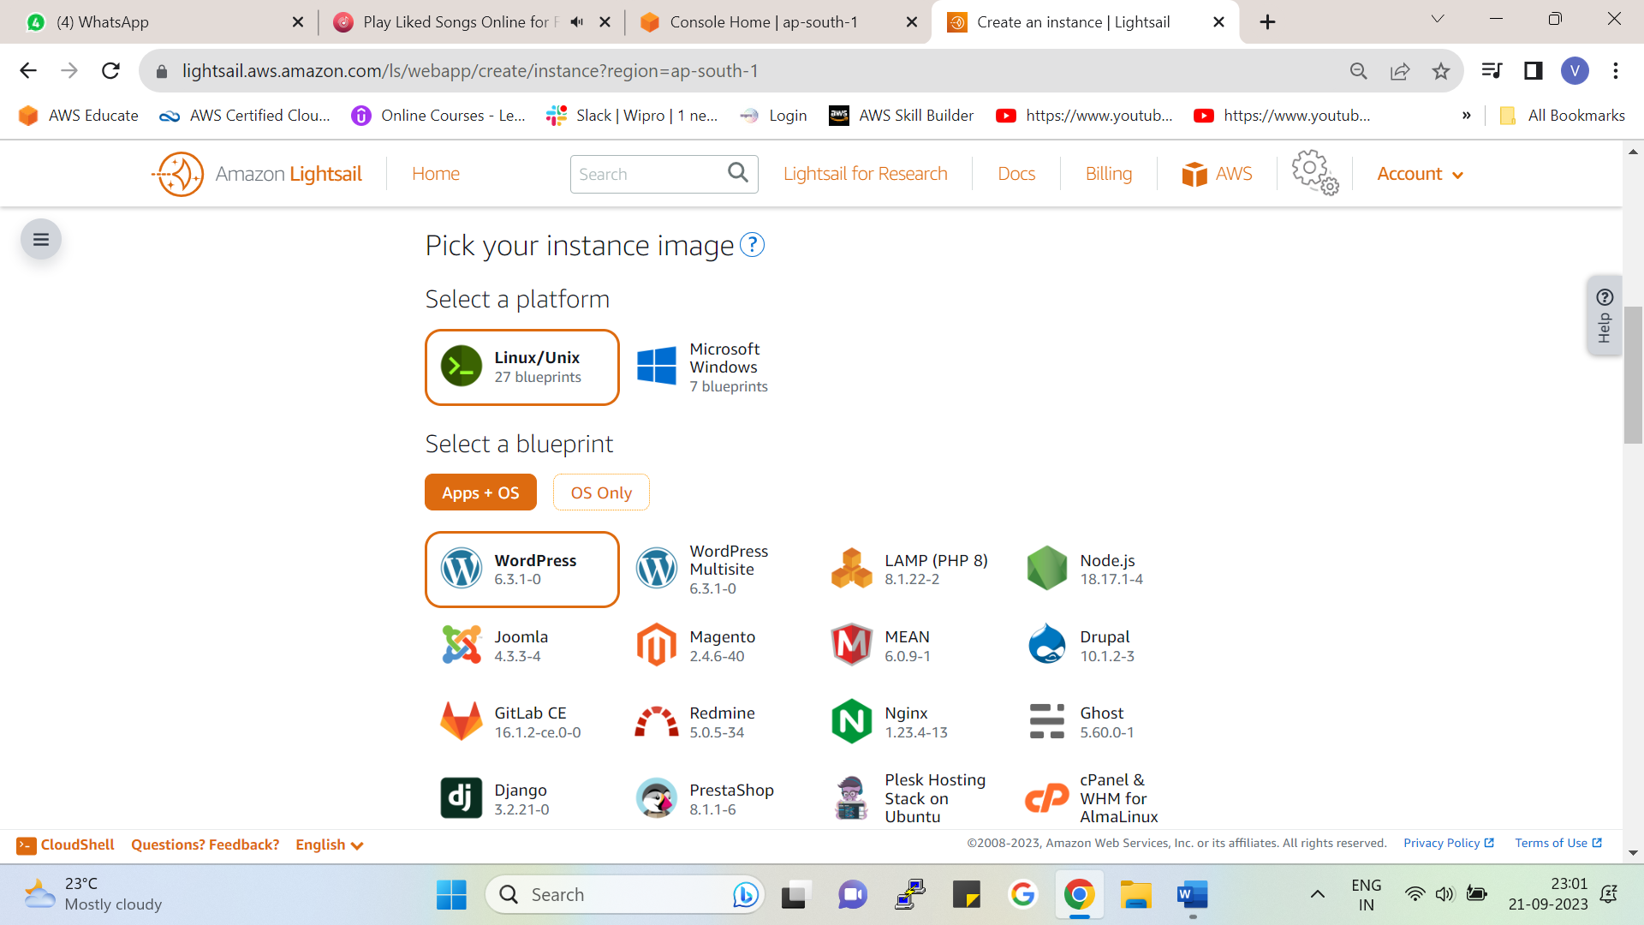

* Pick your instance image and choose the platform in which you want to launch an instance either Linux or Windows.
* In Linux, we have 27 blueprints, and in Windows we have 7 blueprints.
* Blueprints are preconfigured templates

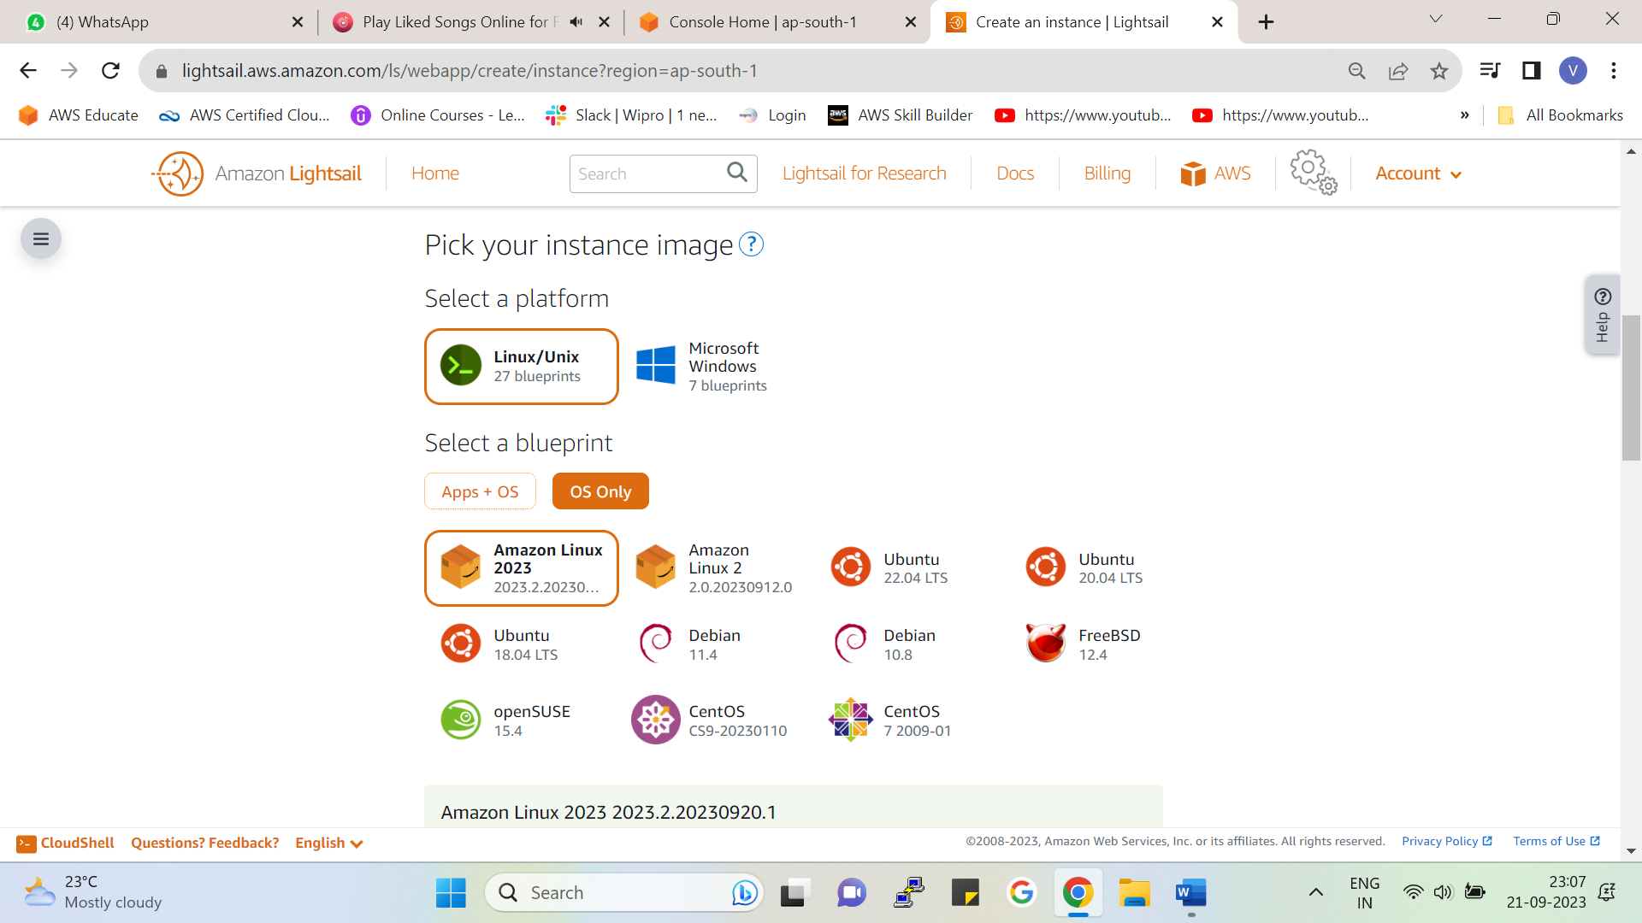

In blueprint type, we have two options available.

1. OS Only 🡪 Here we get only the base operating system here we can install applications of our choice.

As we can see we get multiple OS such as Linux, Ubuntu, CentOS etc.

1. Apps + OS 🡪 Here we get the operating system also we get additional preconfigured applications.

E.g. WordPress, Node.js, GitLab, etc.

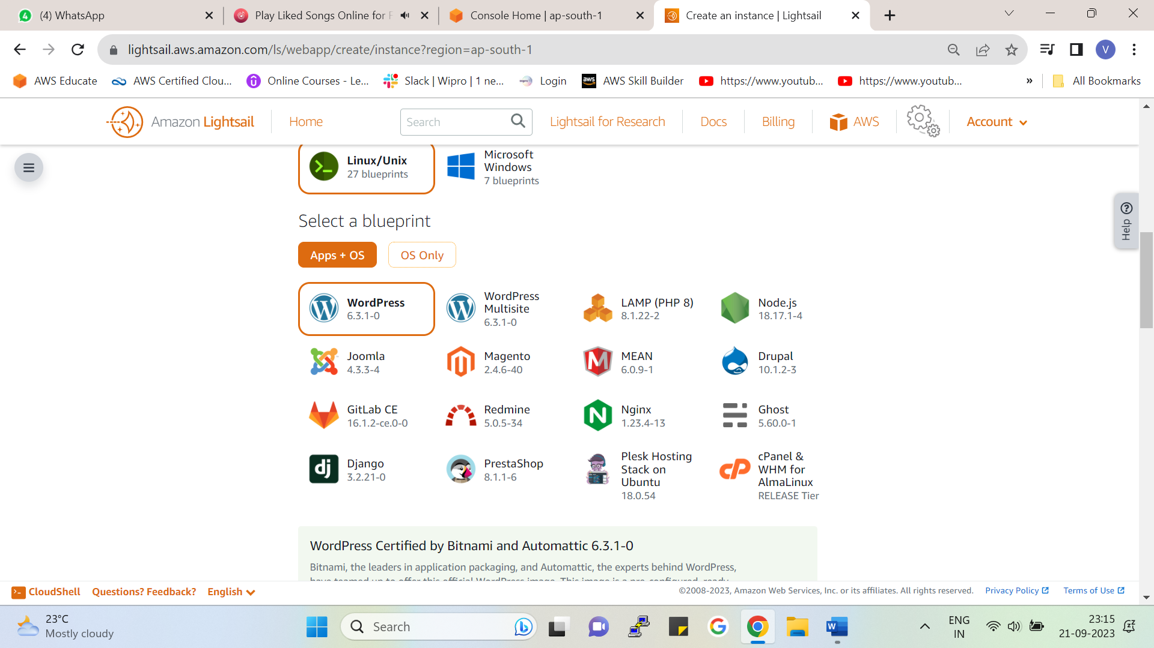

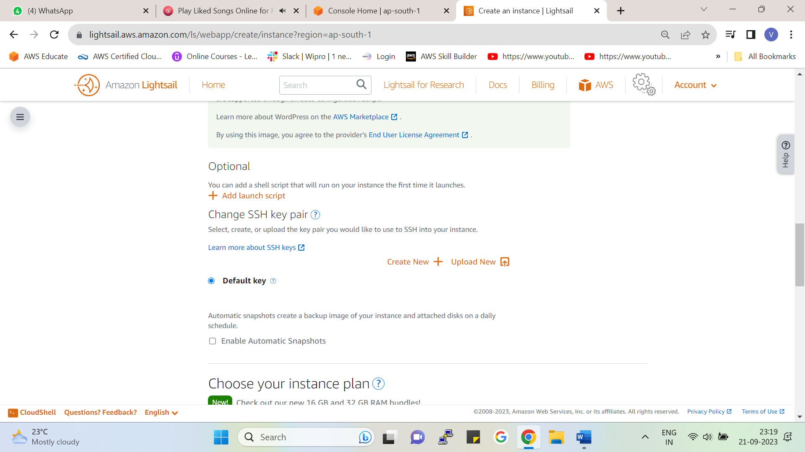

* Here we get the default SSH key Pair to launch our instance you can create a new key pair or also use the default keypair.
* If you want snapshots of your instance, you can tick the checkbox **(enable automatic snapshots) .**

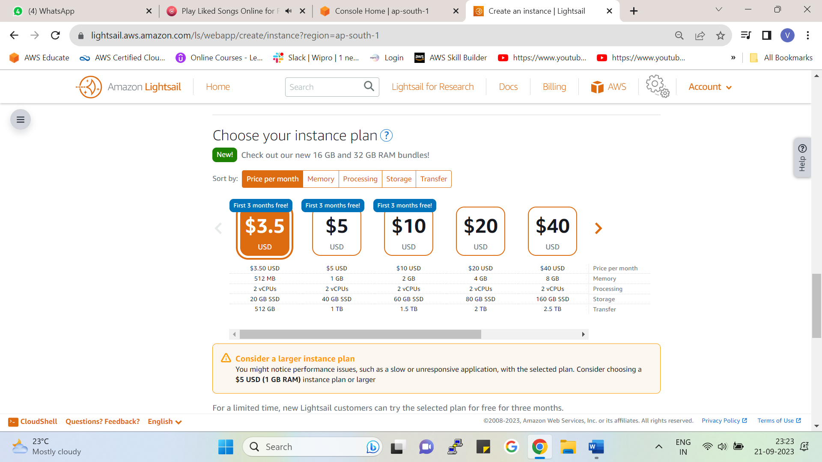

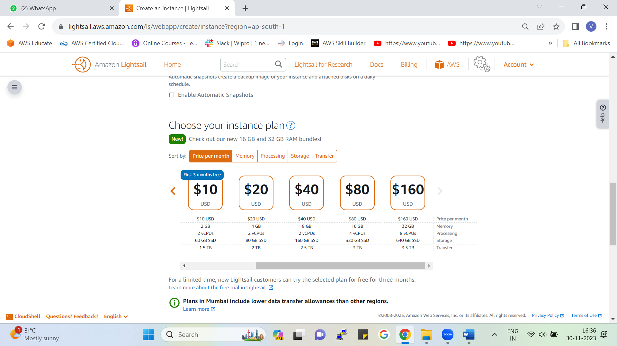

Choose the instance plan you want according to your demand for memory, CPUs, data transfer size, etc, it is free for the first three months.

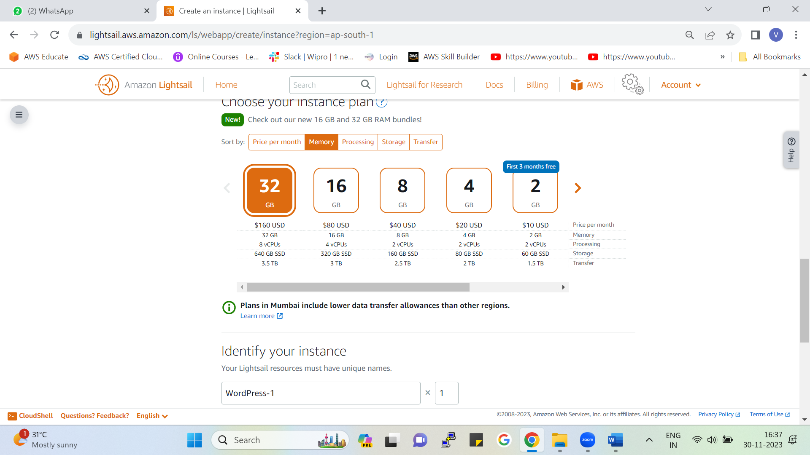

As shown in the figure you can also select pricing depending upon the memory you require.

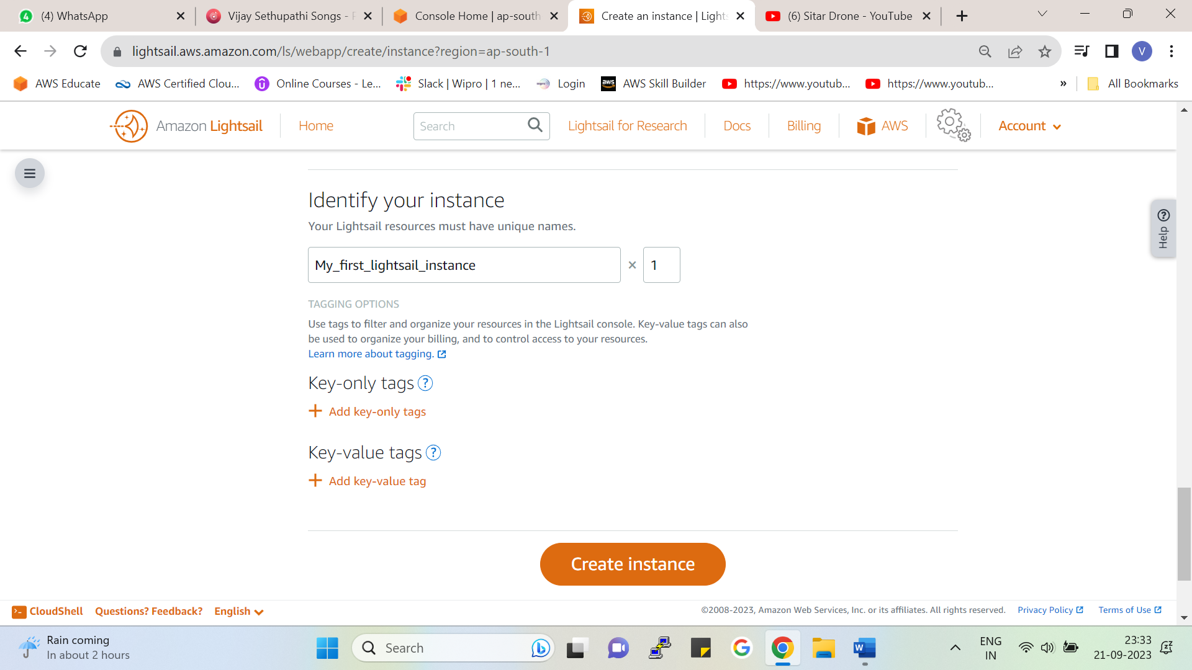

Give the name of your choice to the instance and hit create instance you can also add tags to your instance.

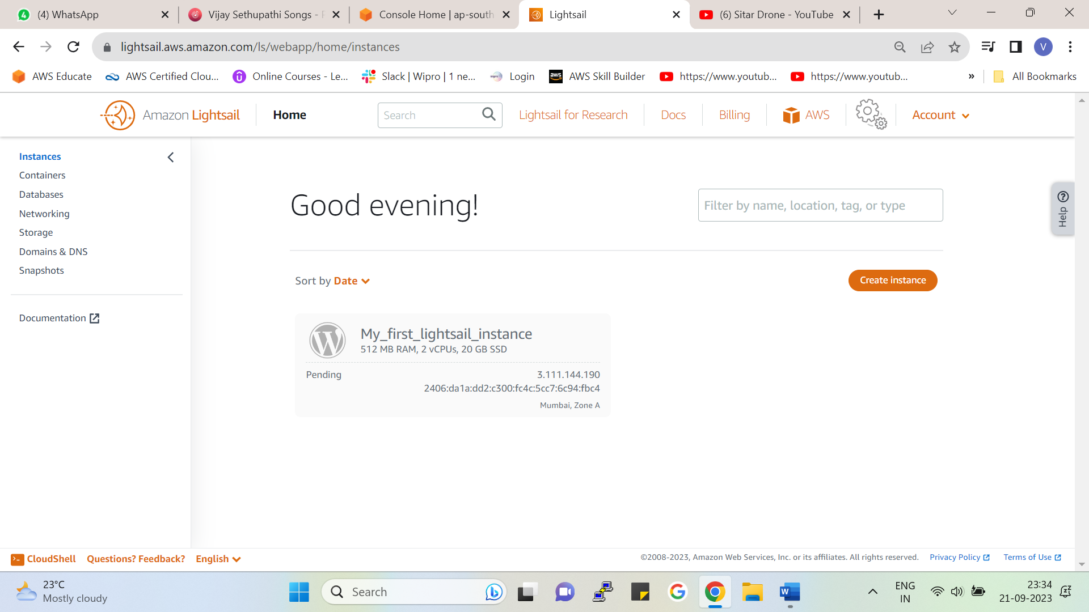

Instance creation in progress.

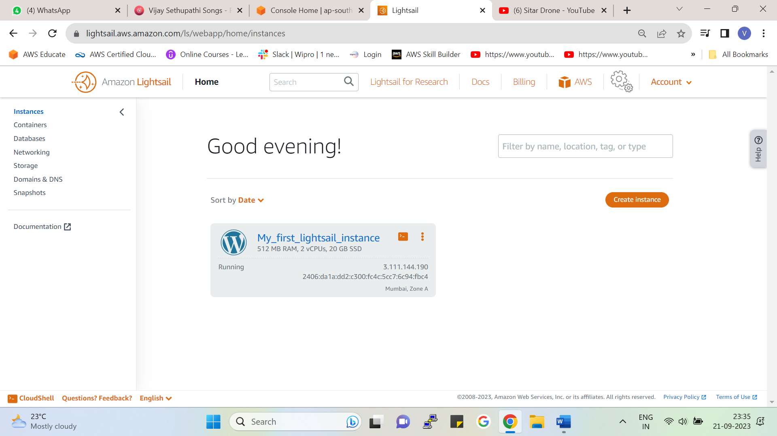

The instance has been created successfully.

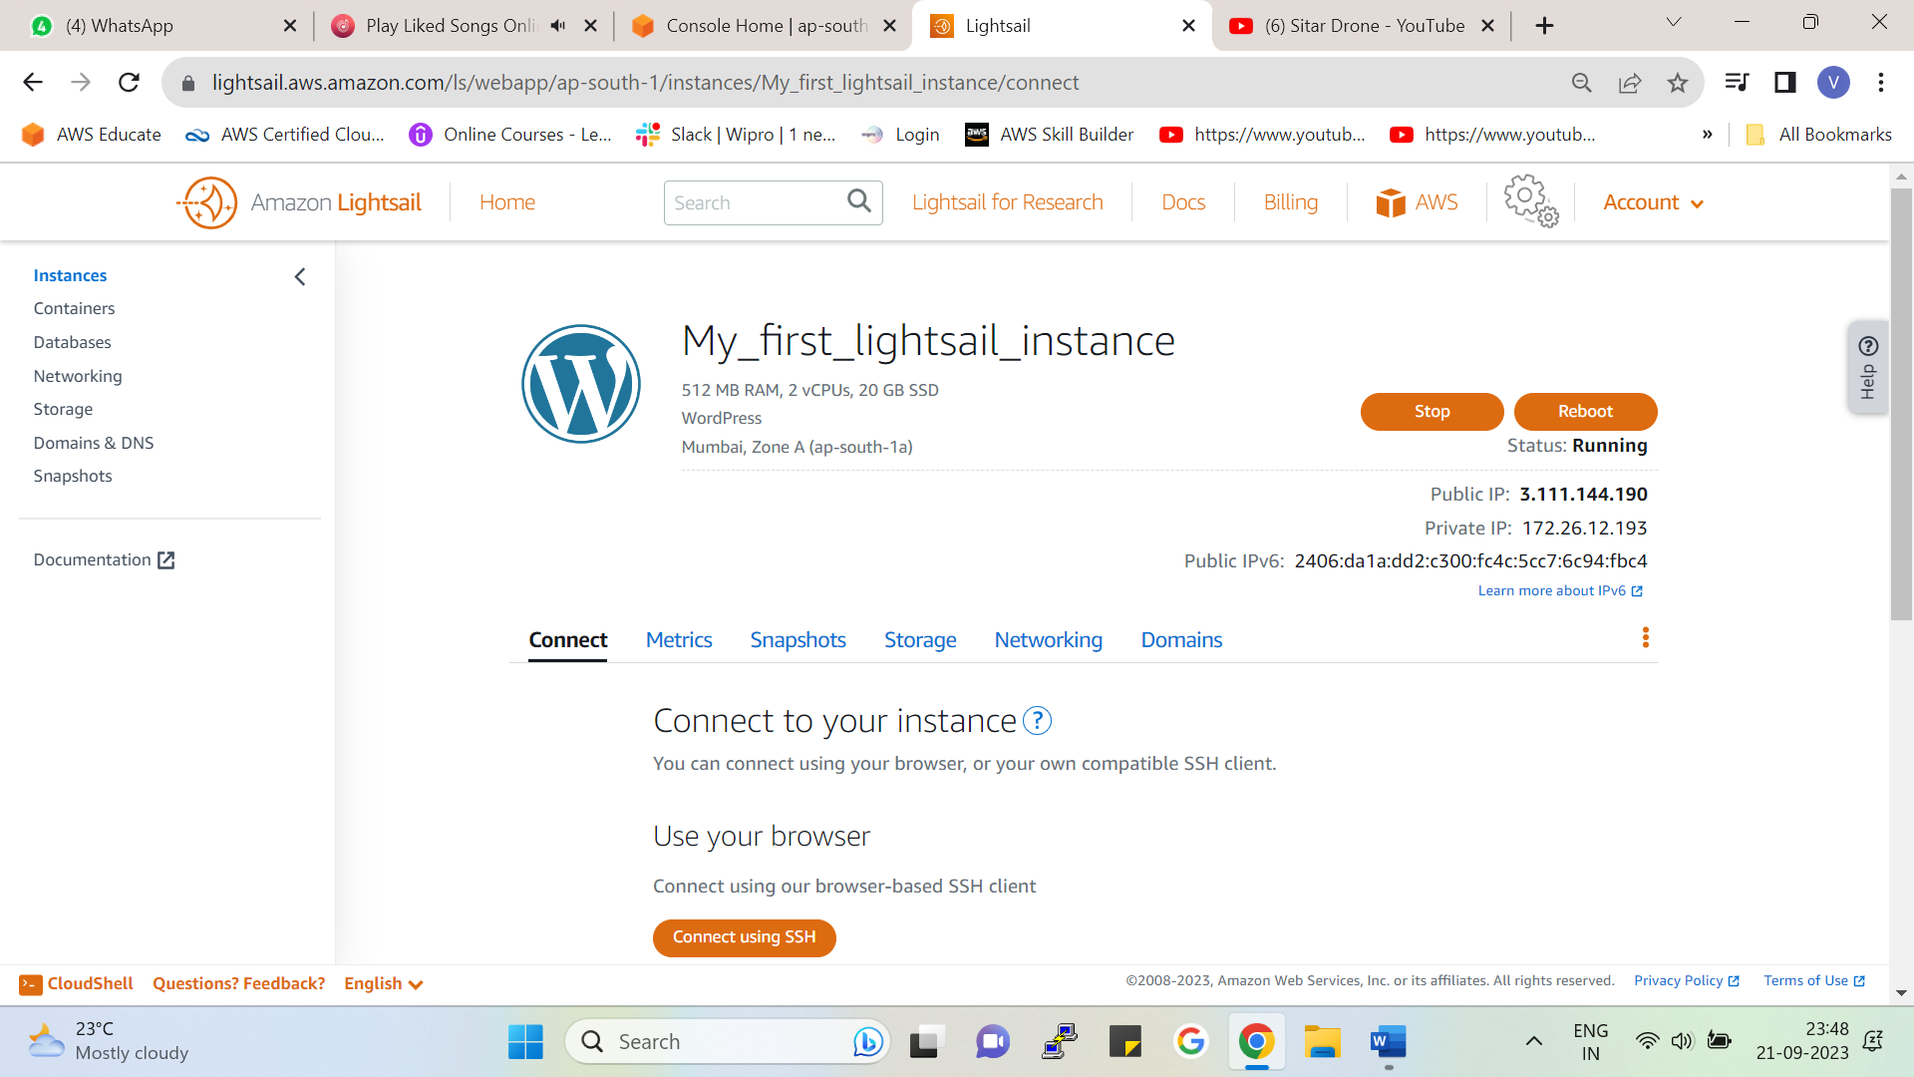

By clicking on the instance, we can see our Public IPV4, Private IPV4 also IPV6, the public IP always changes while the Private IP is constant.

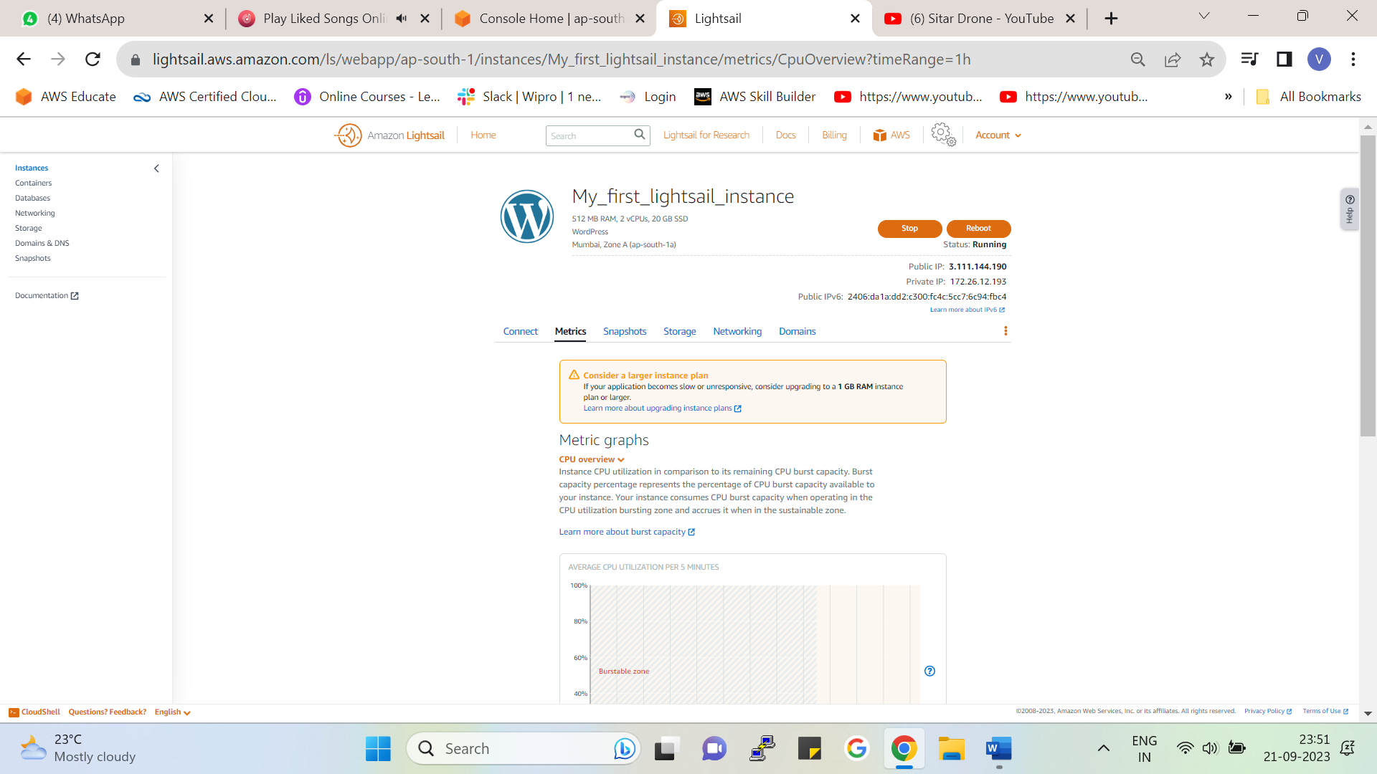

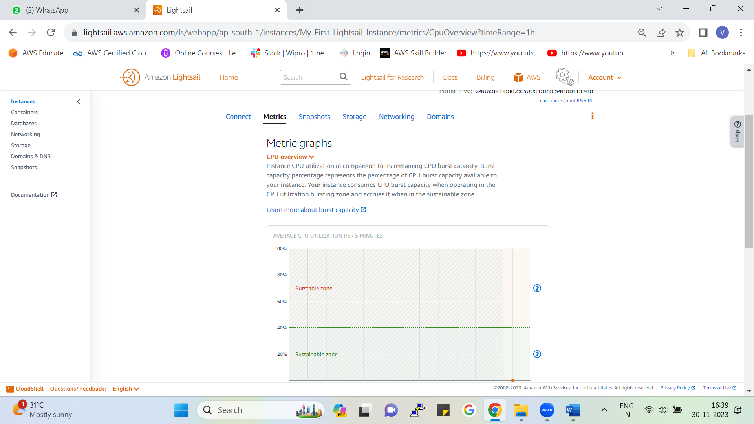

Here you will get metrics graph according to the usage of your instance.

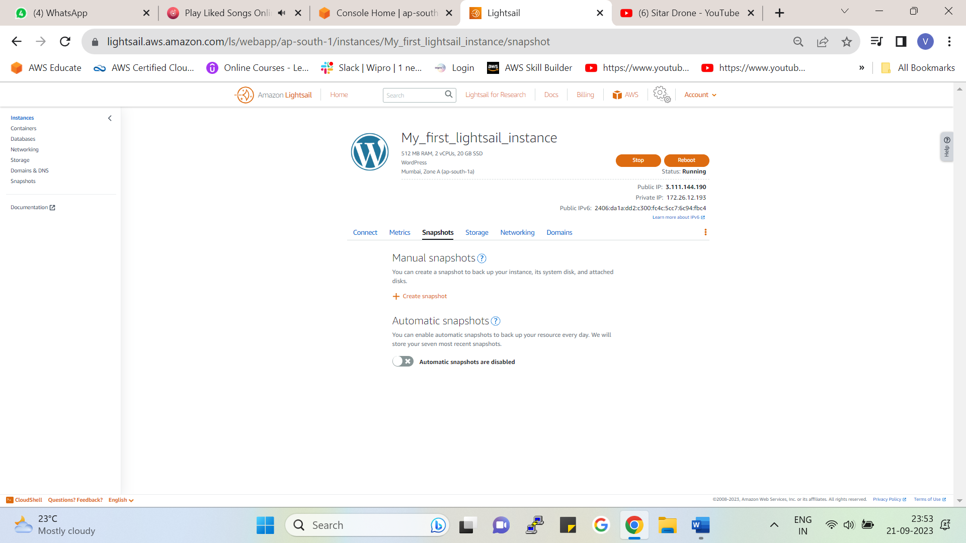

From here we can manually create snapshot of our instance

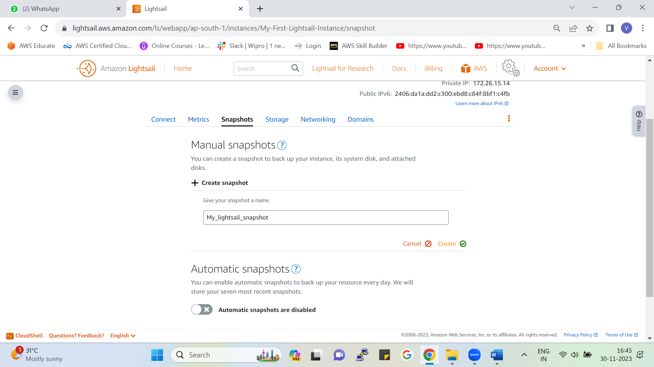

* Give the name to you snapshot and hit create
* You can also enable automatic snapshots option to take backup of your instance every day.

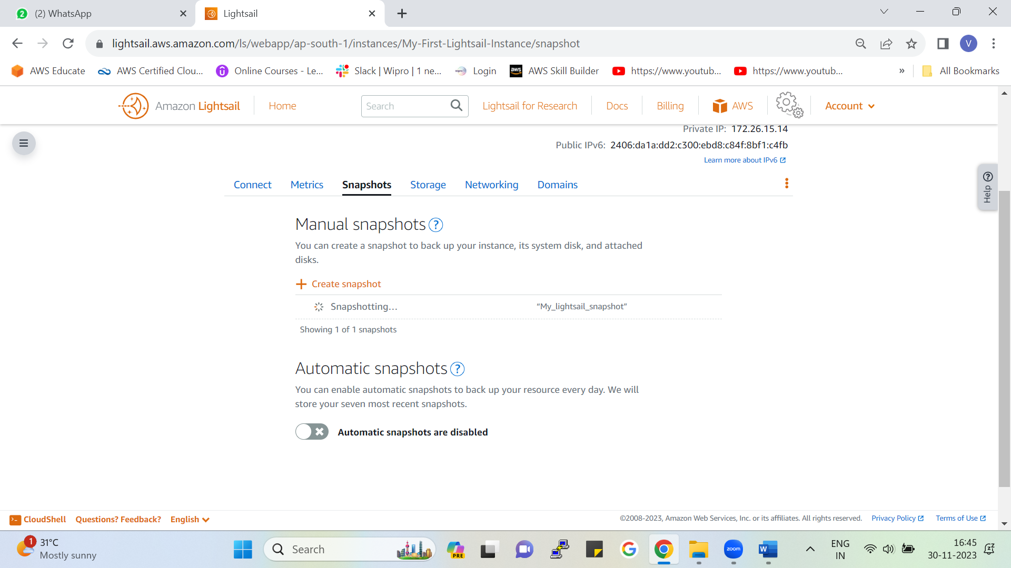

As we can see snapshot creation is in progress.

As we can see we have not enabled the automatic snapshots option so no snapshots will be stored.

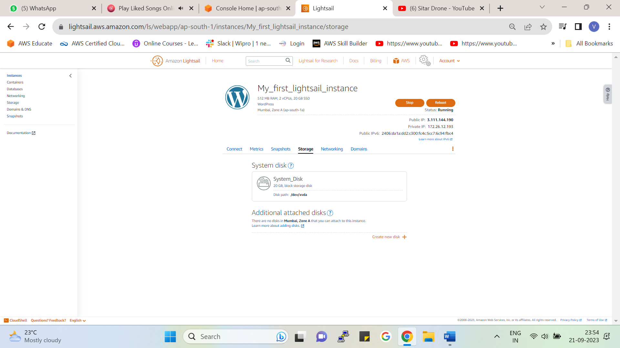

Instances🡪 Storage 🡪 From here we can create an additional disk by clicking on create new disk

The 20GB block storage is the default disk of our instance

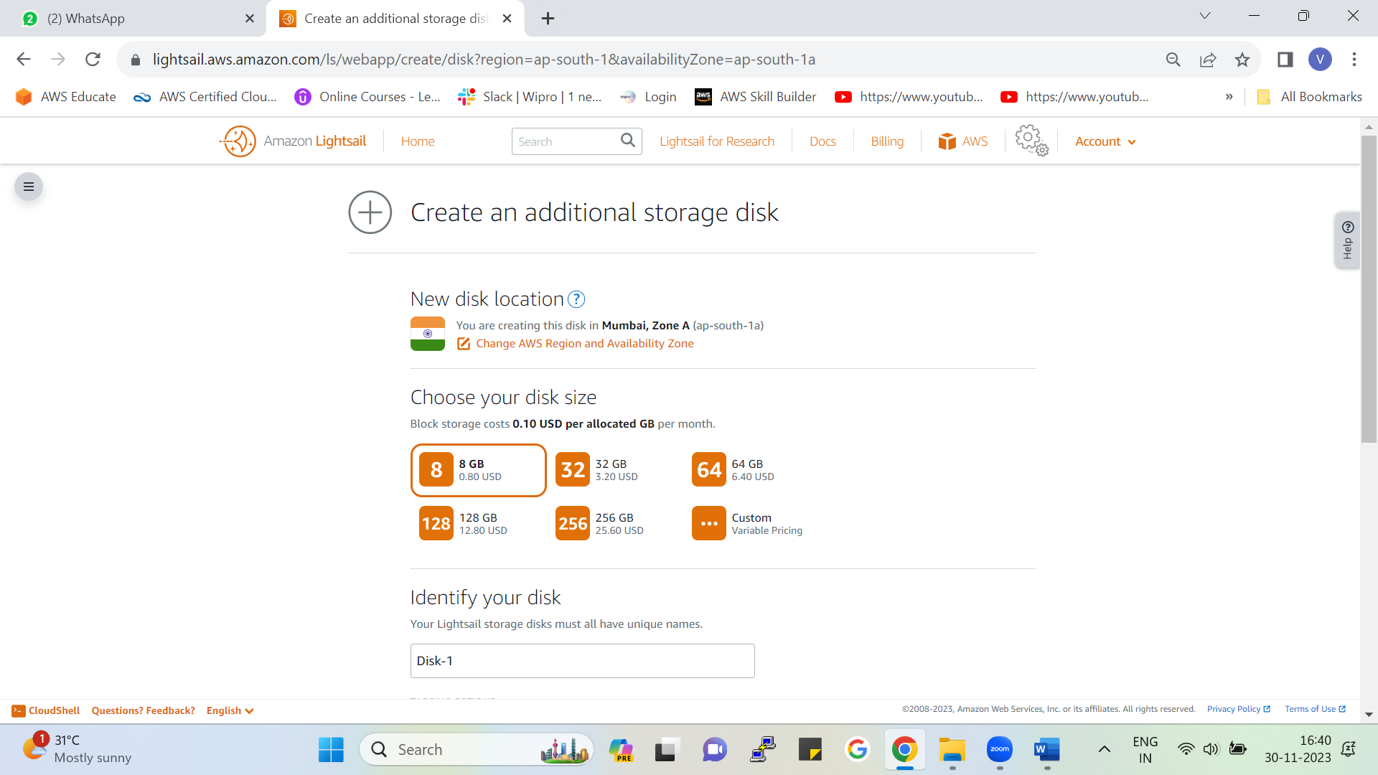

To add new disk we need to specify the size , region /AZ and name of the disk.

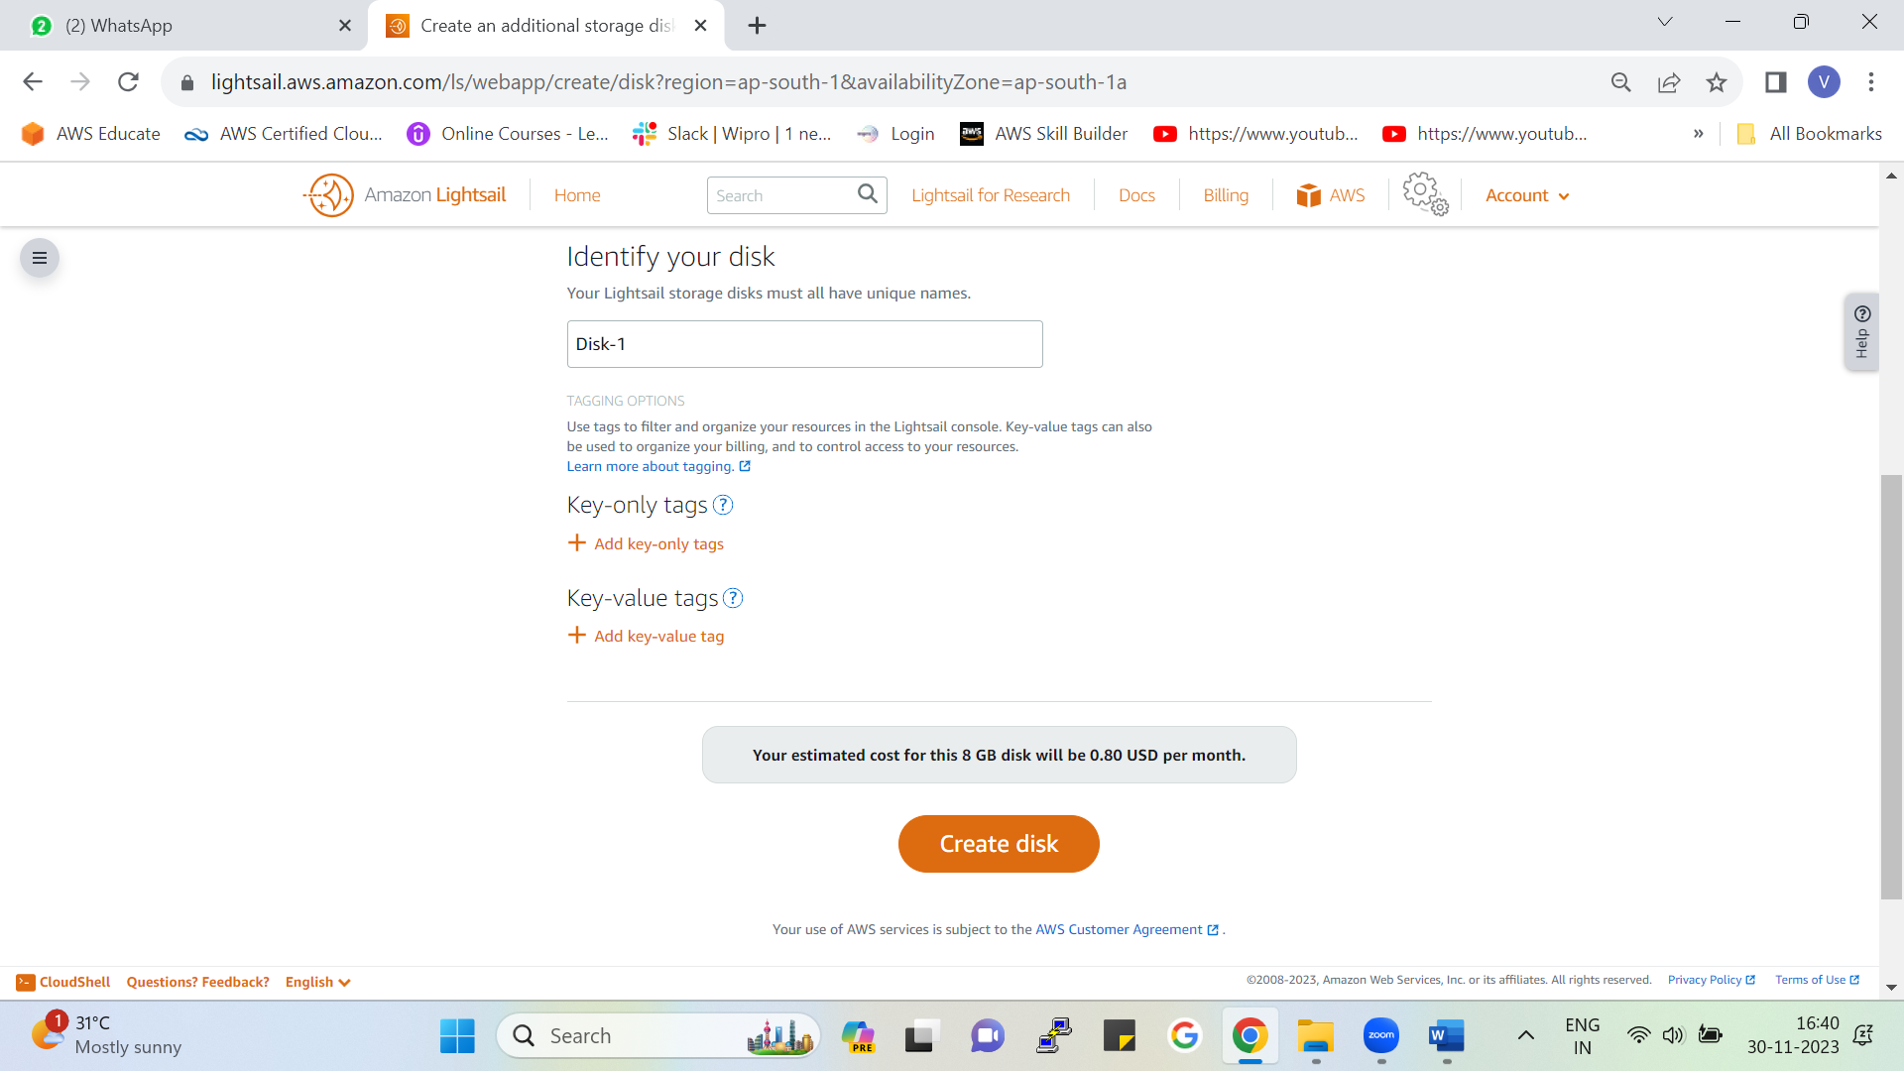

Give name to your additional disk add tags if you want and click on create.

This is our storage disk if we want it in the future, we can also create a new disk.

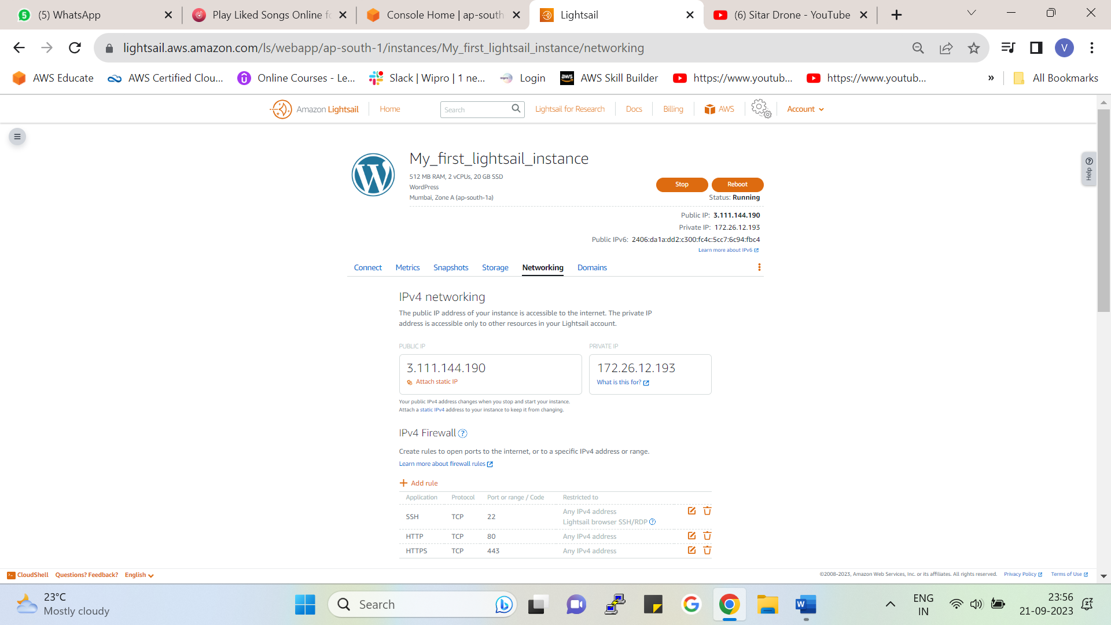

Instances🡪Networking🡪As we can see this is our public IP which is not constant to make it constant Click on attach static IP

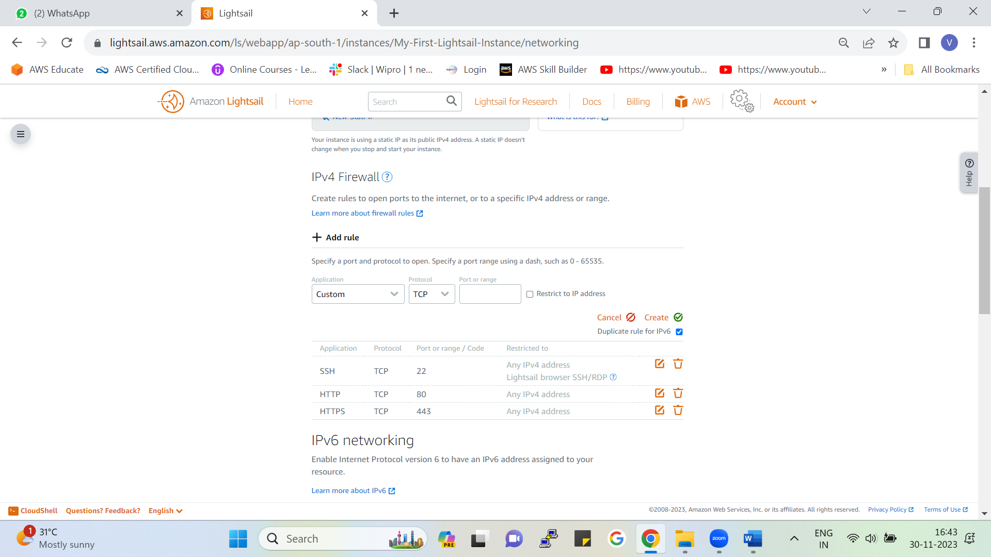

You can add or delete the rule for your instance from the networking section

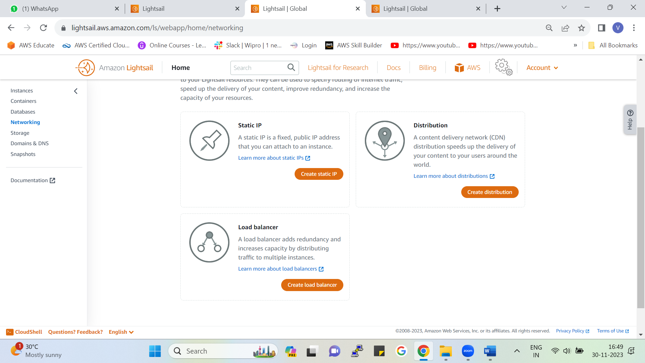

Going on the networking from here also you can create a static IP, Load Balancer, CDN for your instance.

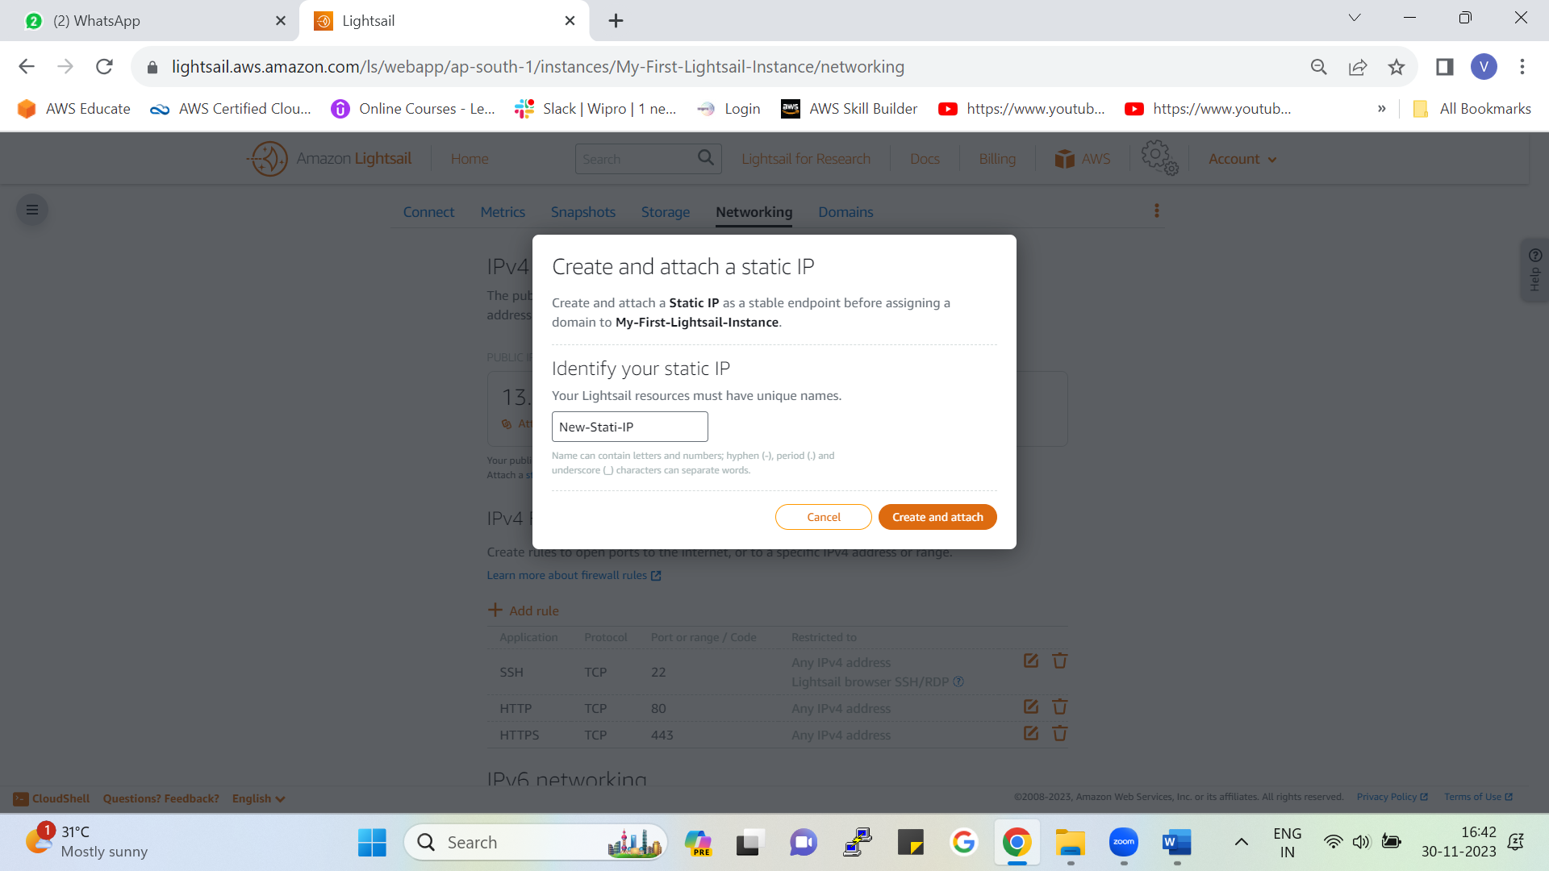

* Give name to your static IP and click on create and attach
* By this static IP will be attached to our instance

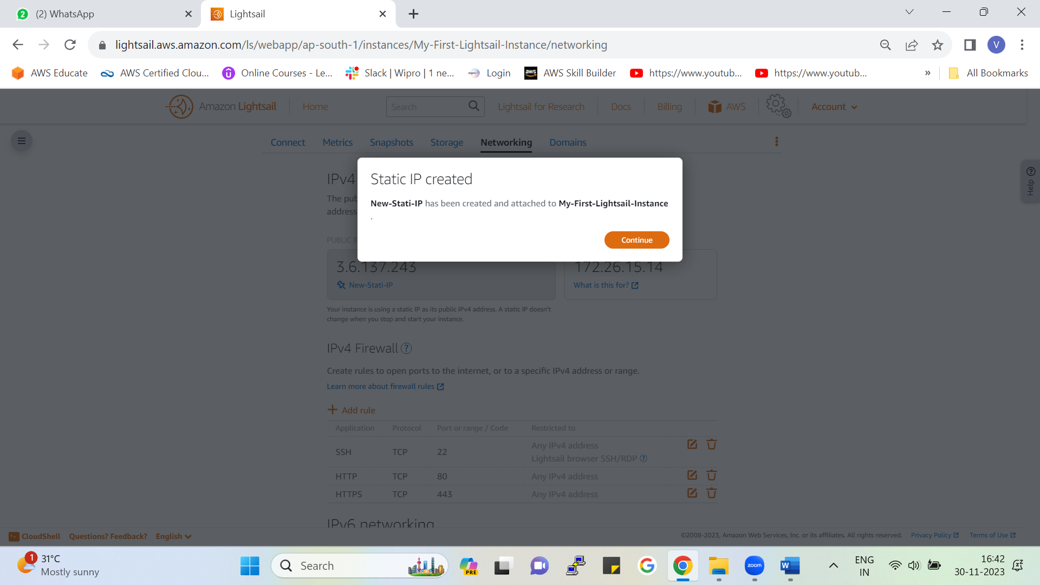

Created successfully

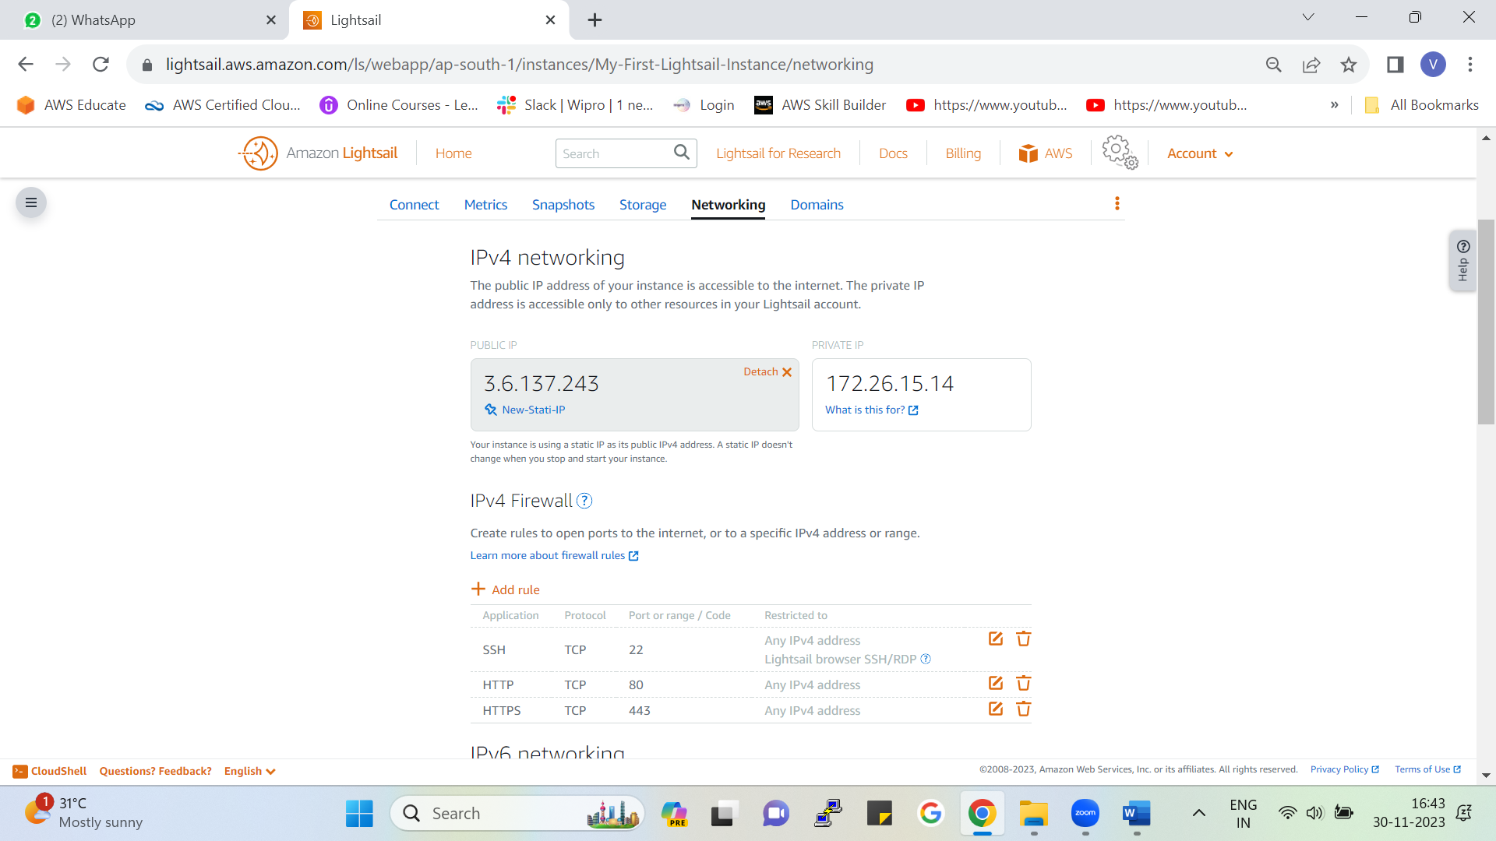

* Before static IP- 3.111.144.190
* After static IP – 3.6.137.243
* Due to this static IP our public IP will be constant even if you stop or start the instance

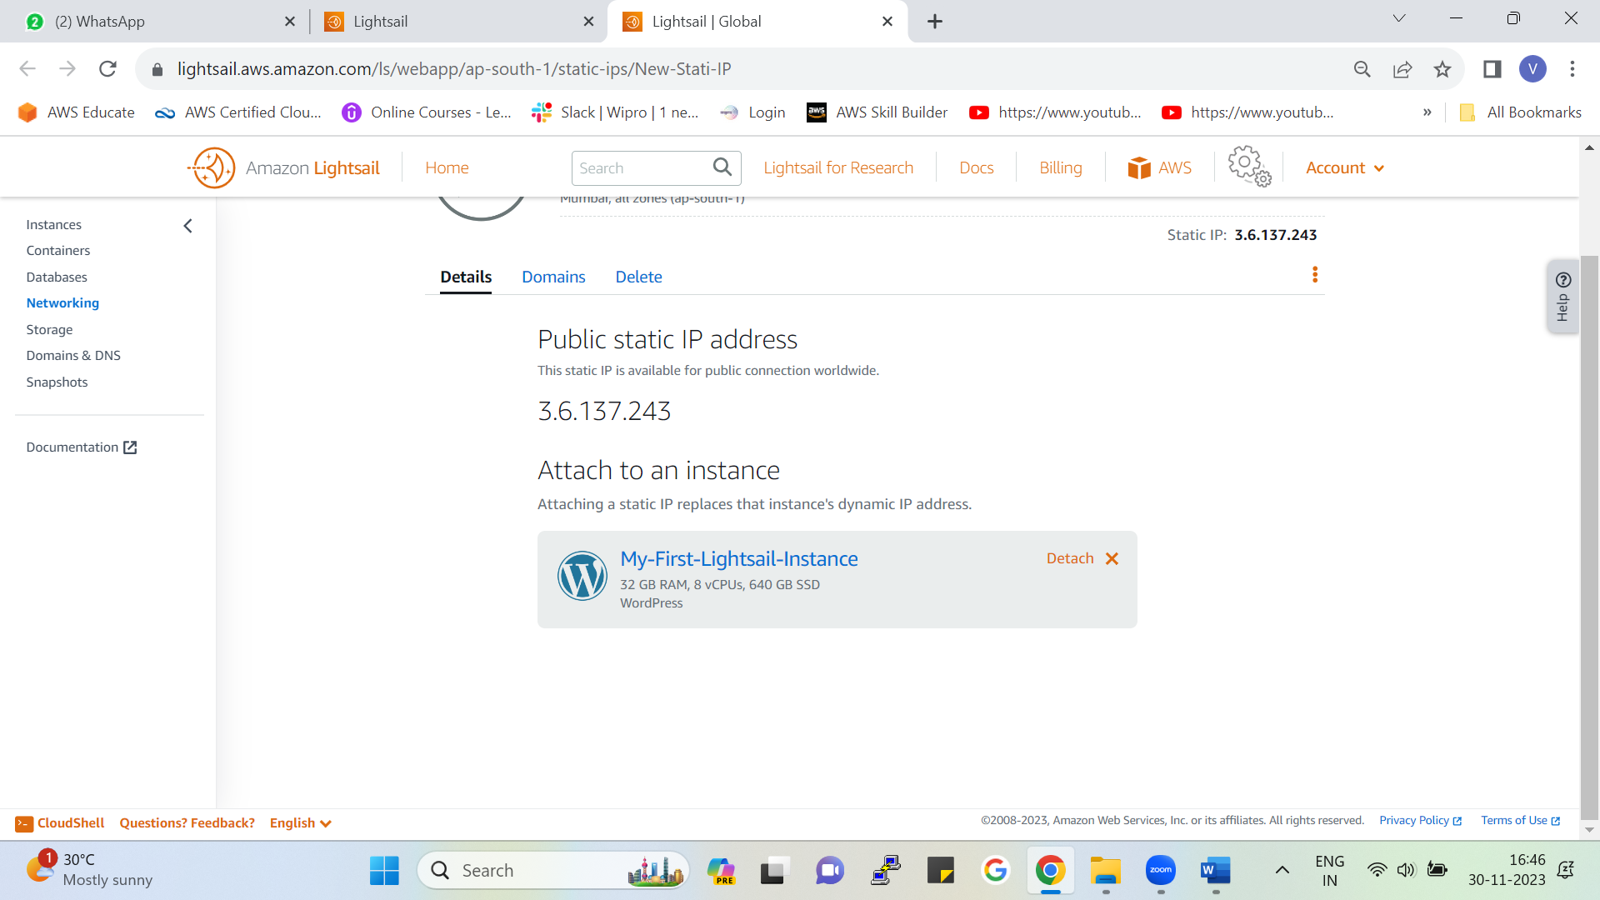

By clicking on networking, you can view details on static IP.

You can also detach the static IP from here.

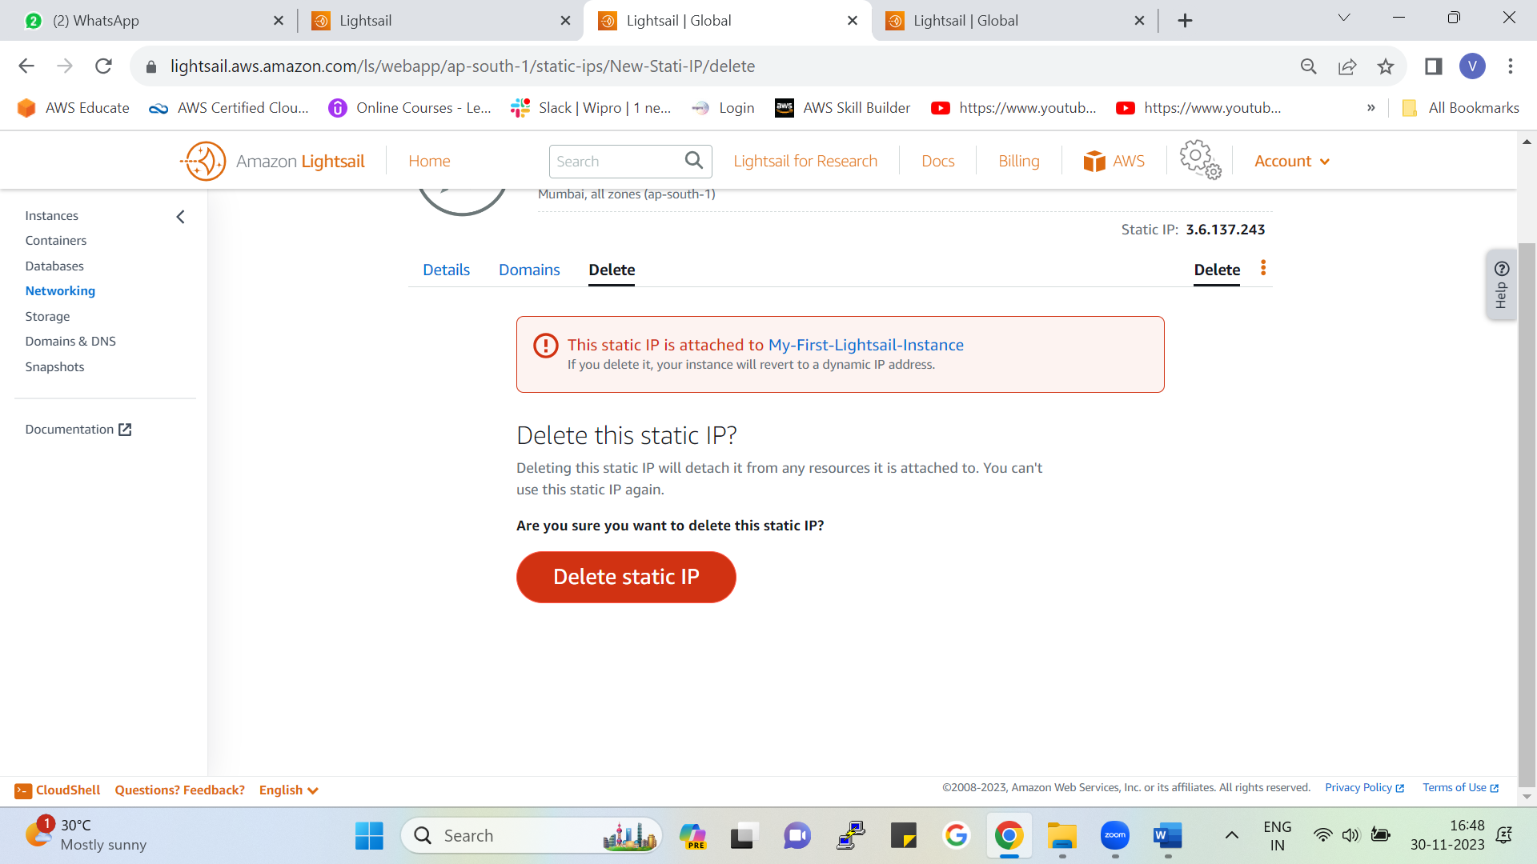

From here you can delete static IP

**Note:**

As our public IP always changes, we can attach a static IP so that our IP address will not change.



Networking🡪 From here we can create load balancer.

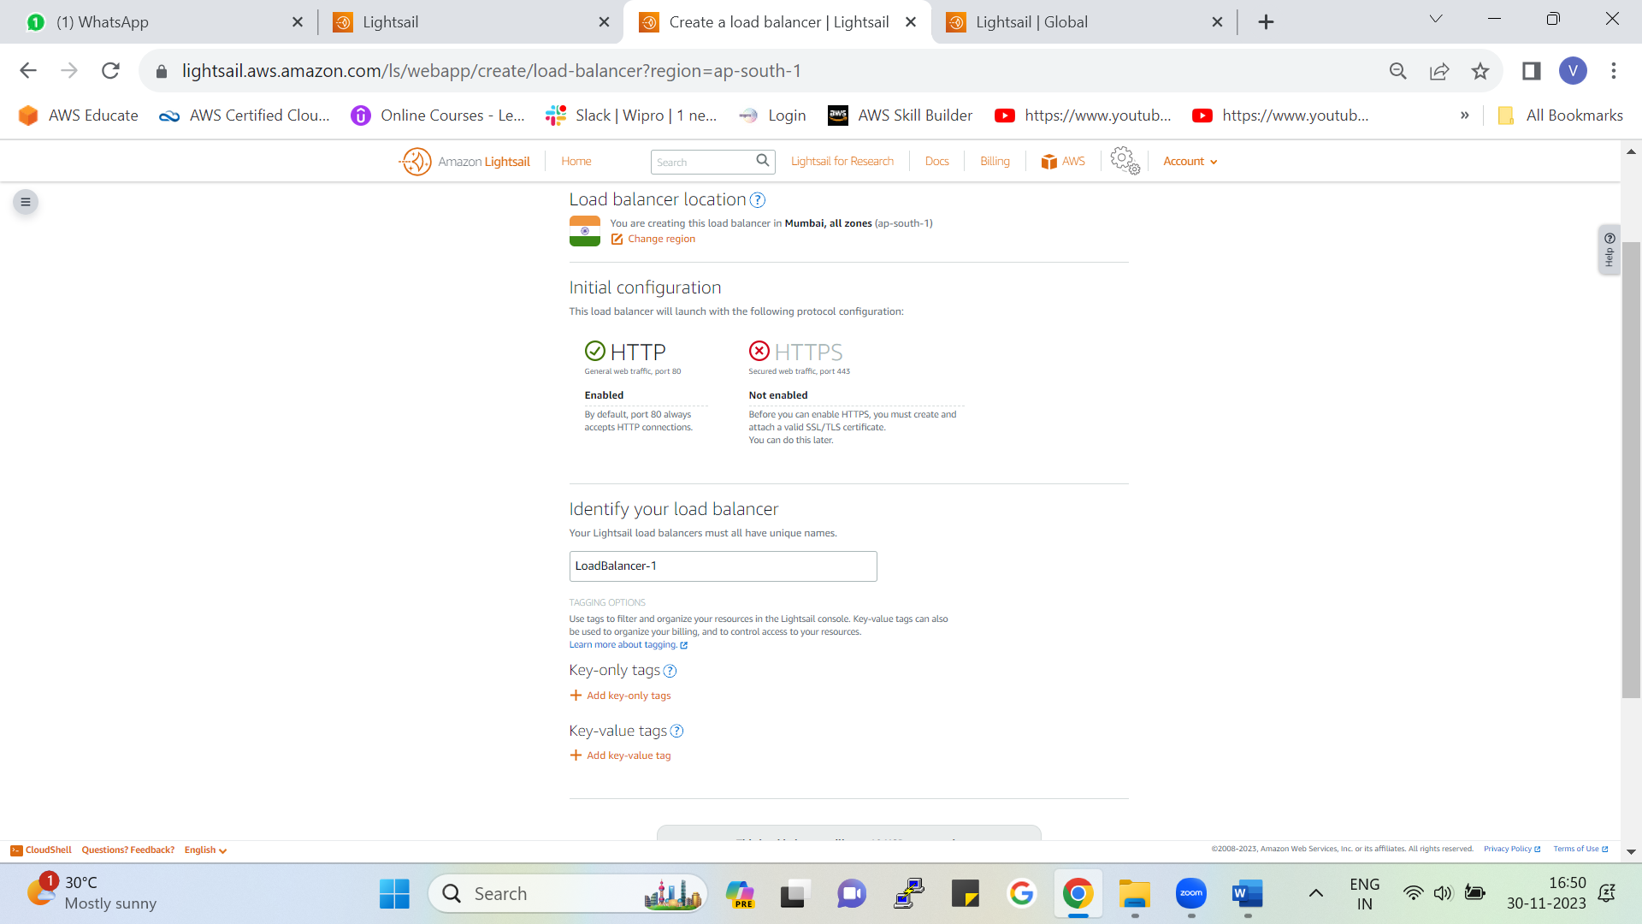

Load balancer is used to distribute the incoming traffic between your servers.

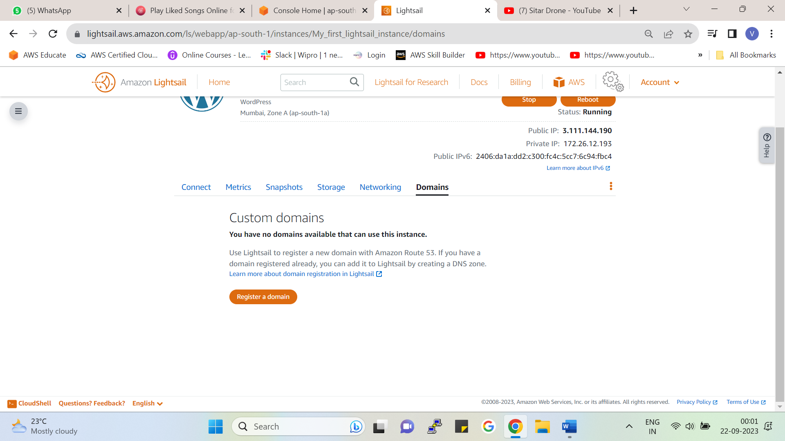

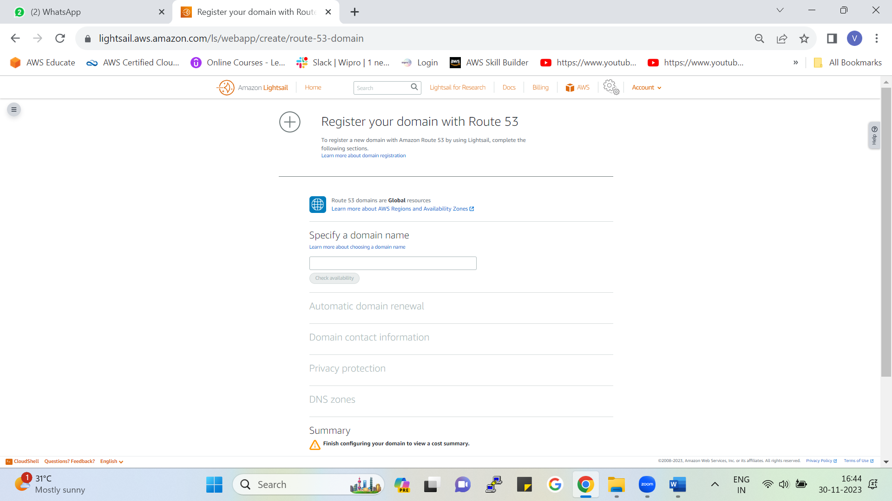

* We can register a domain name for your website.
* Domain names are paid.
* In AWS Route 53 is used for DNS (domain name server).

## Connecting to WordPress (Webpage) through EC2

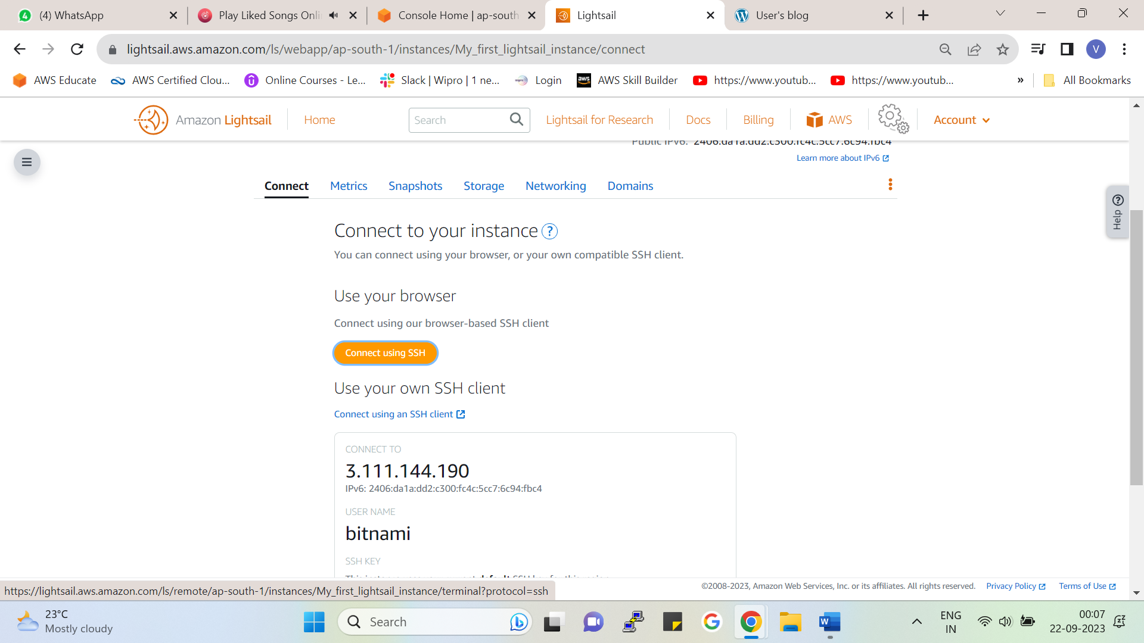

By clicking connect to SSH we will be connected with our instance

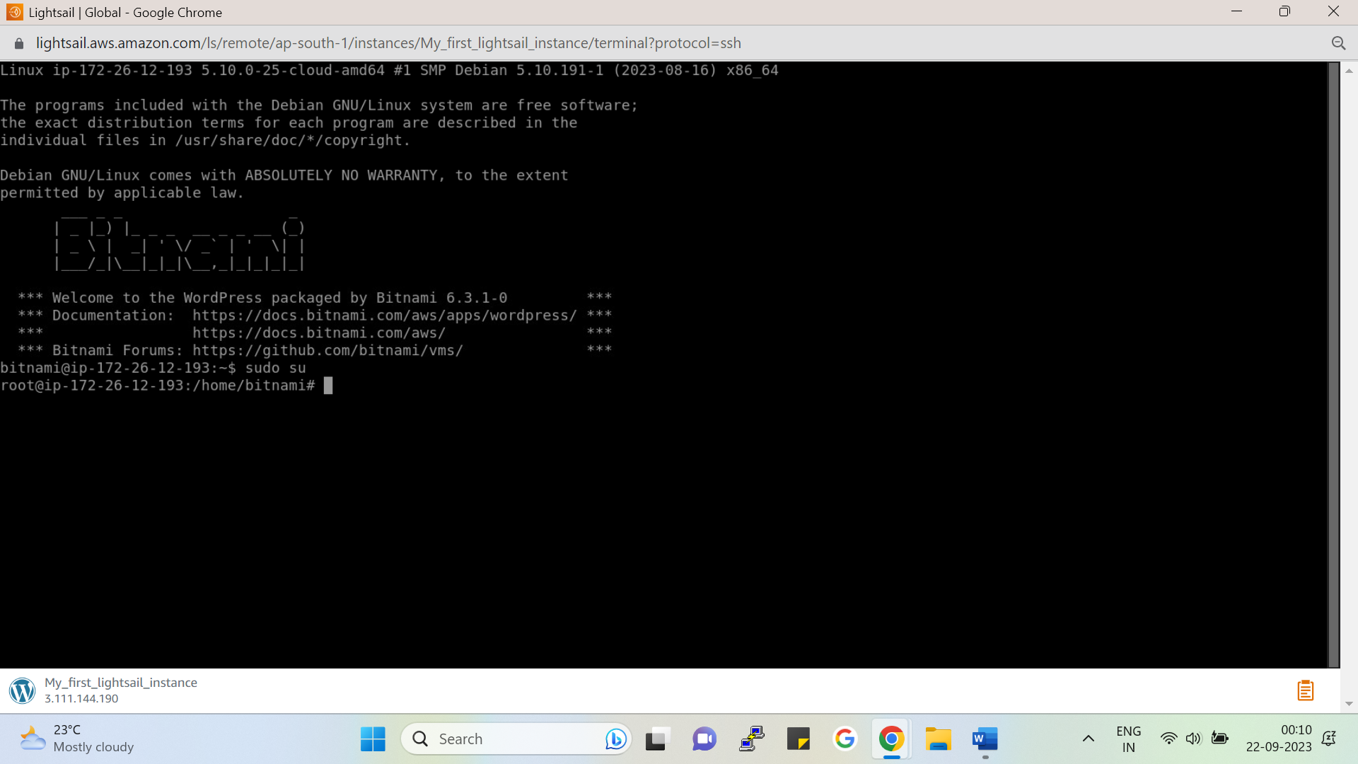

By following command, we will go inside home and will get the root permissions.

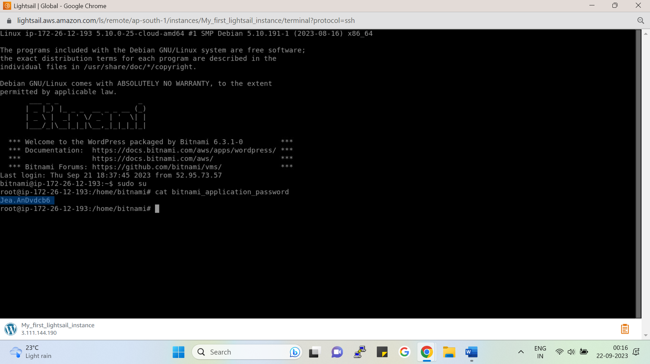

By following the command, we will get our password for logging into WordPress site.

Following is the document link for Amazon lightsail:

<https://lightsail.aws.amazon.com/ls/docs/en_us/articles/amazon-lightsail-tutorial-launching-and-configuring-wordpress>

http://PublicIpAddress/wp-login.php

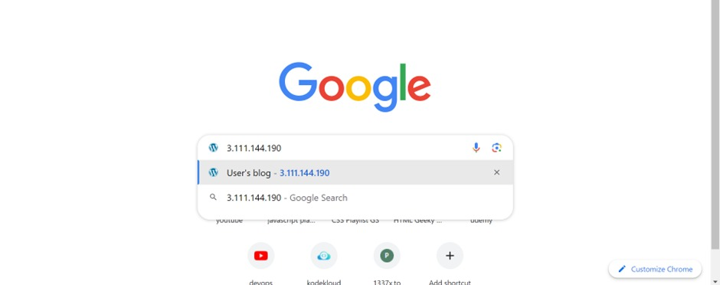

By pasting our Public IP, we will get our webpage.

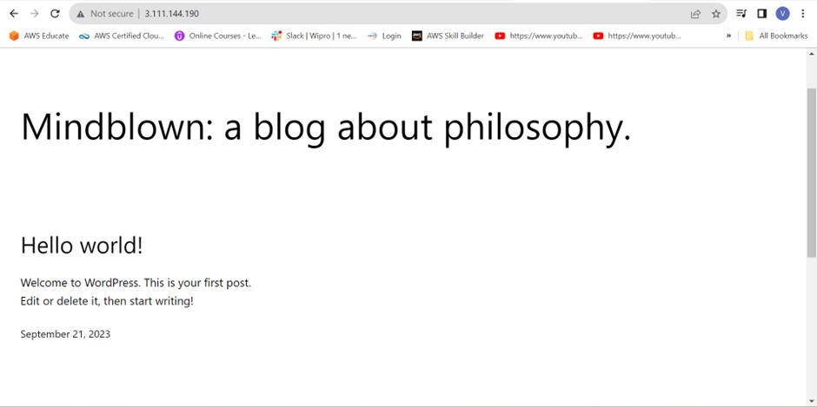

We will get the following WordPress Page after pasting our public IP on google.

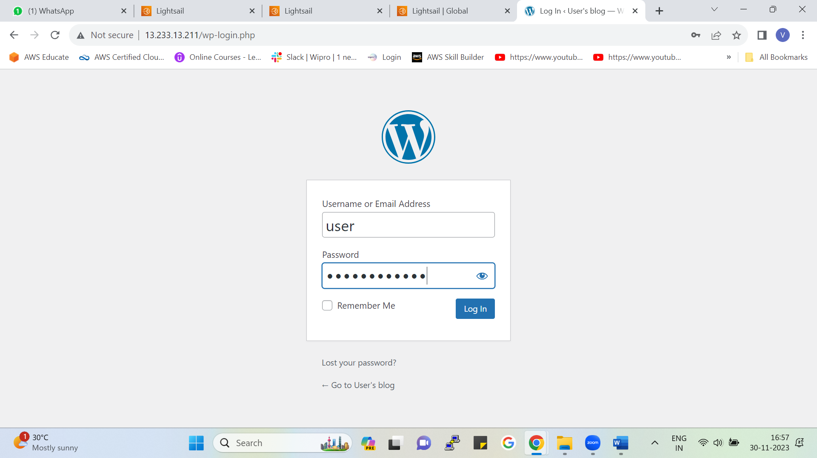

* Put your Public IP address of lightsail to login into WordPress.
* Put the username and password (which we generated from the instance connect) and login

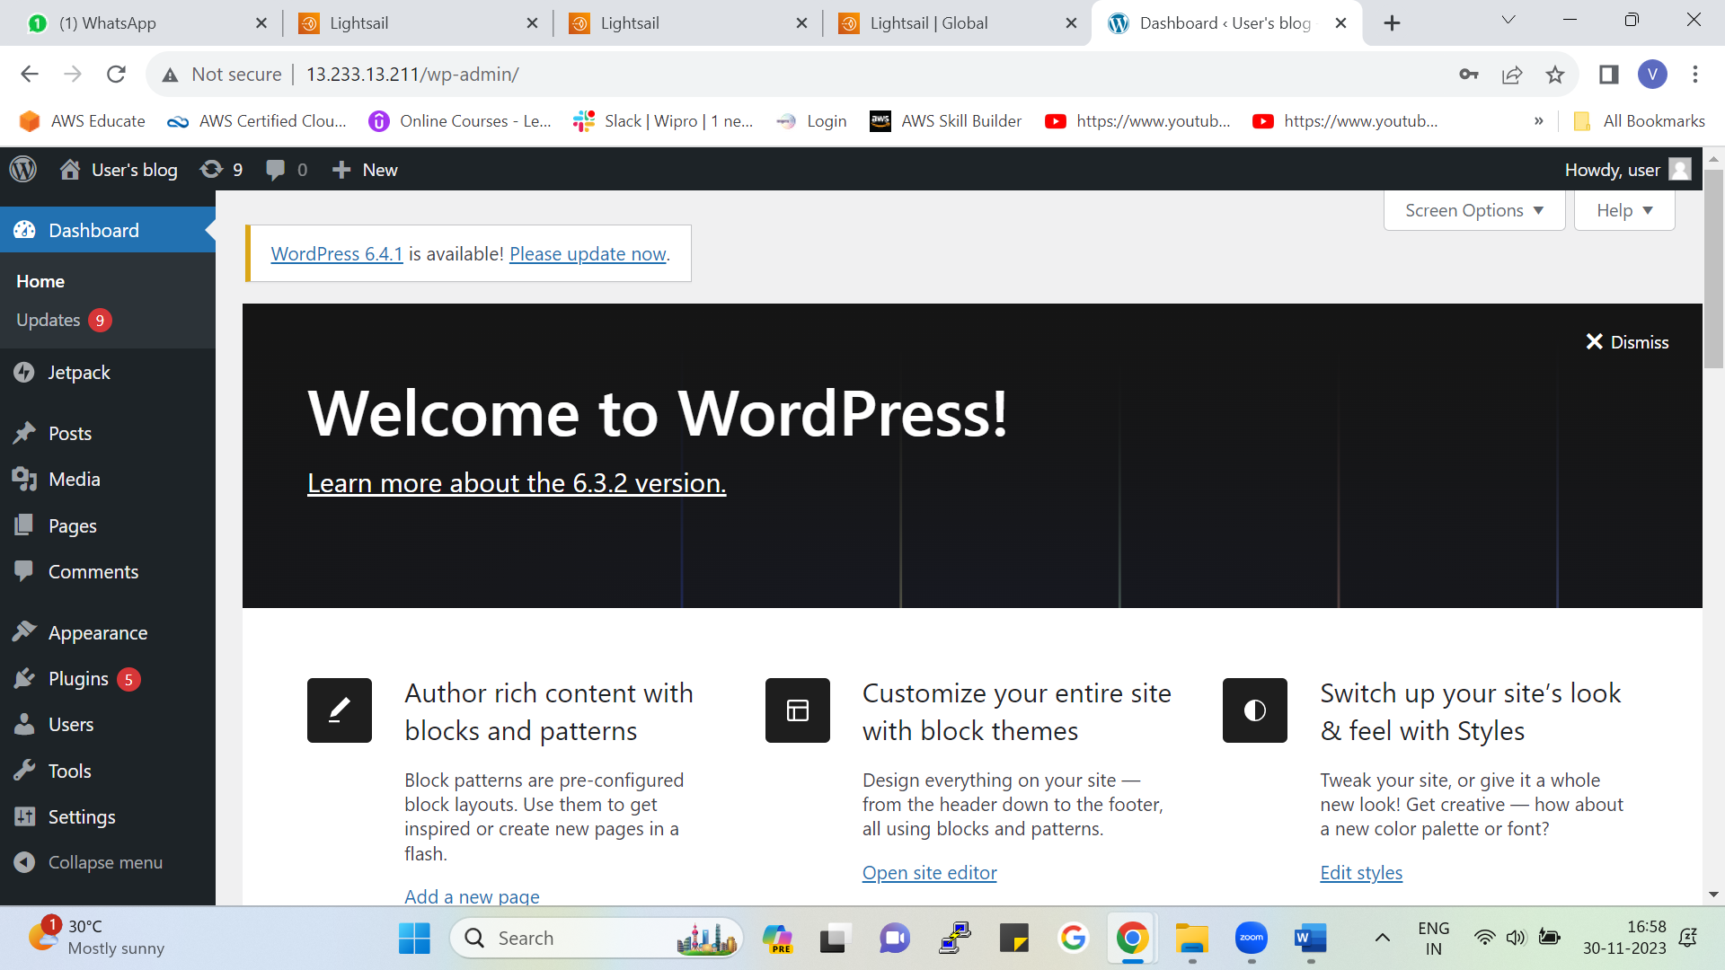

After login following page of the WordPress (admin) will appear if you want to customize the webpage click on (Customize your entire site with block themes).

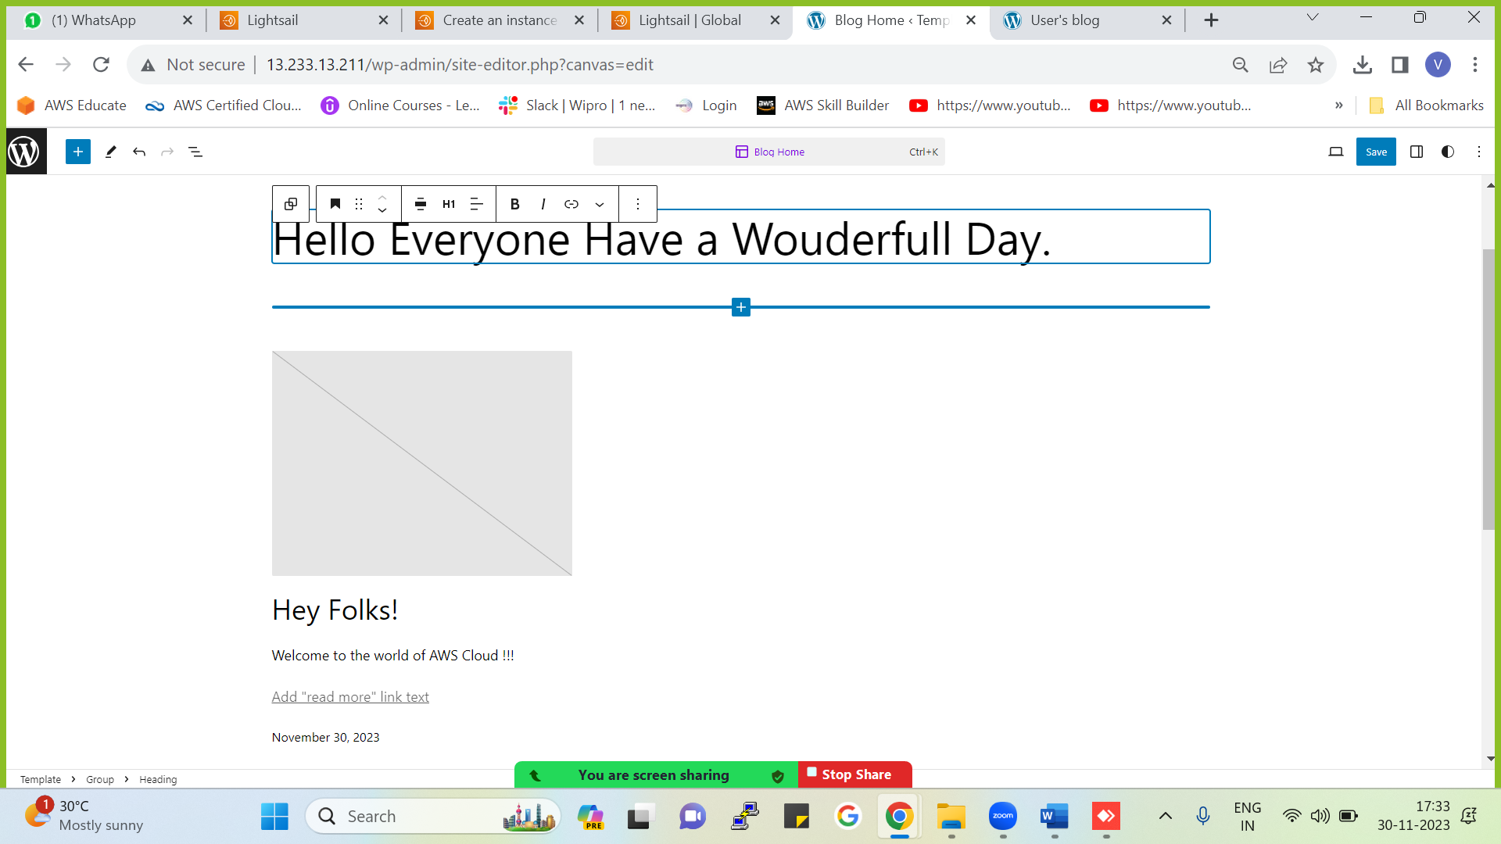

Edit the changes from here for your Webpage

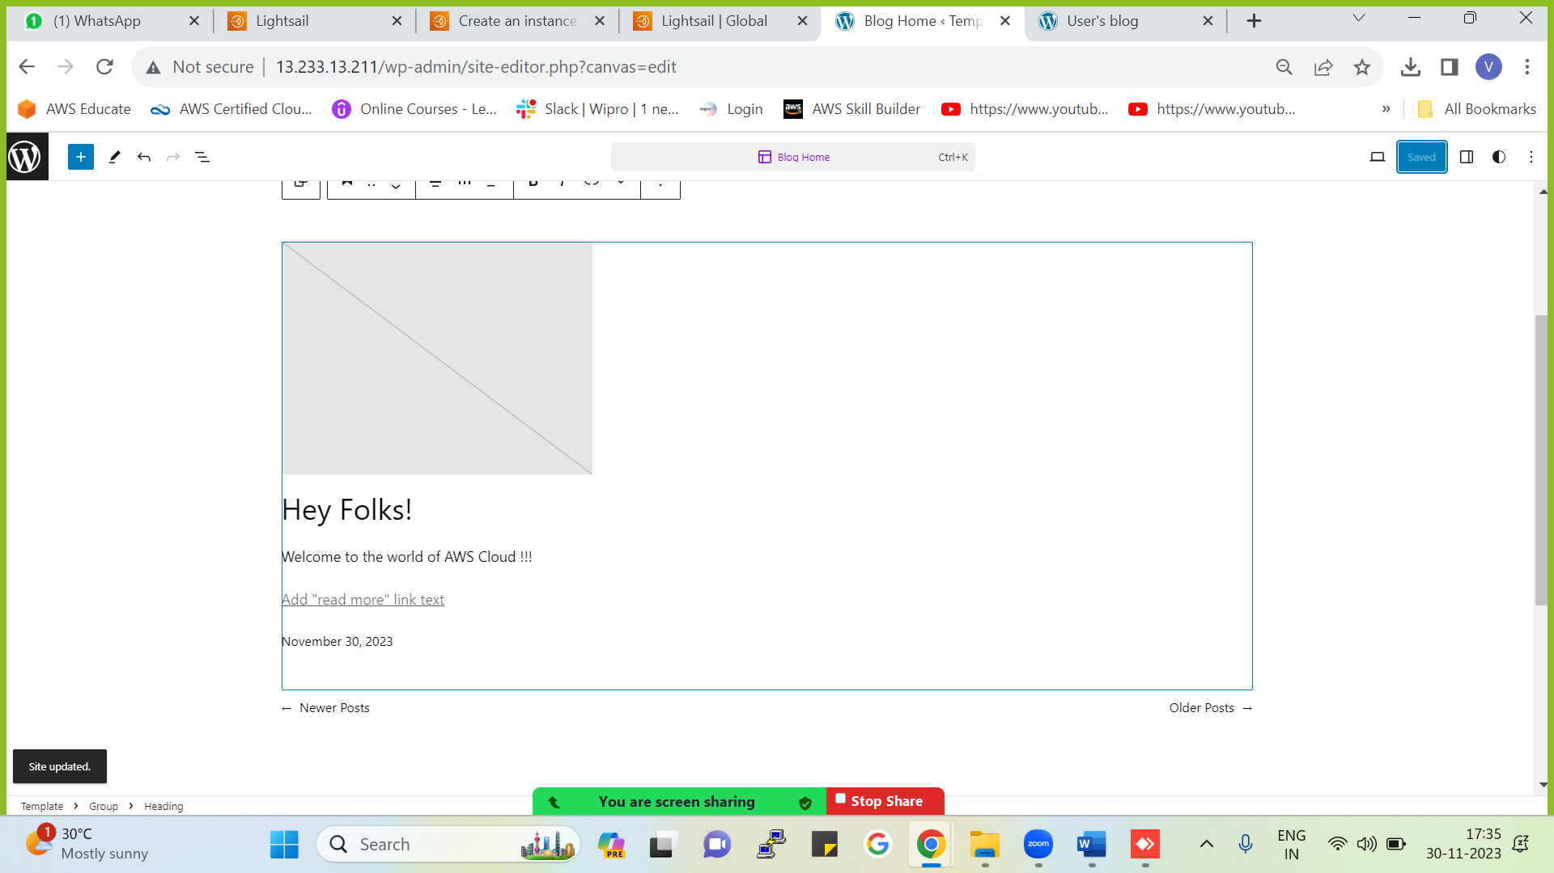

After editing the changes click on save and the new changes will get updated into the webpage

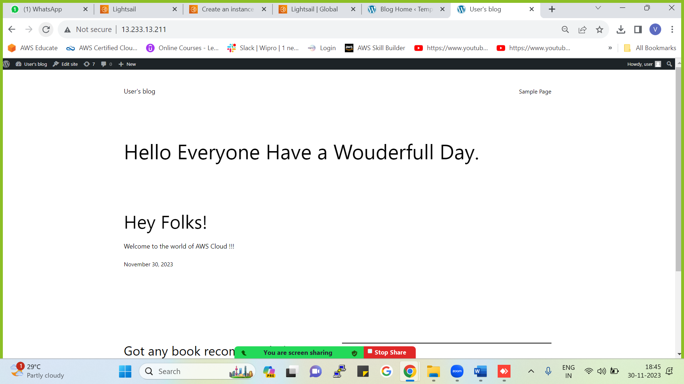

After Updating the edited Web page (here we need to paste the public IP address on google.com to see the updated page).

Editted webpage appeared on google.com from our public IP.

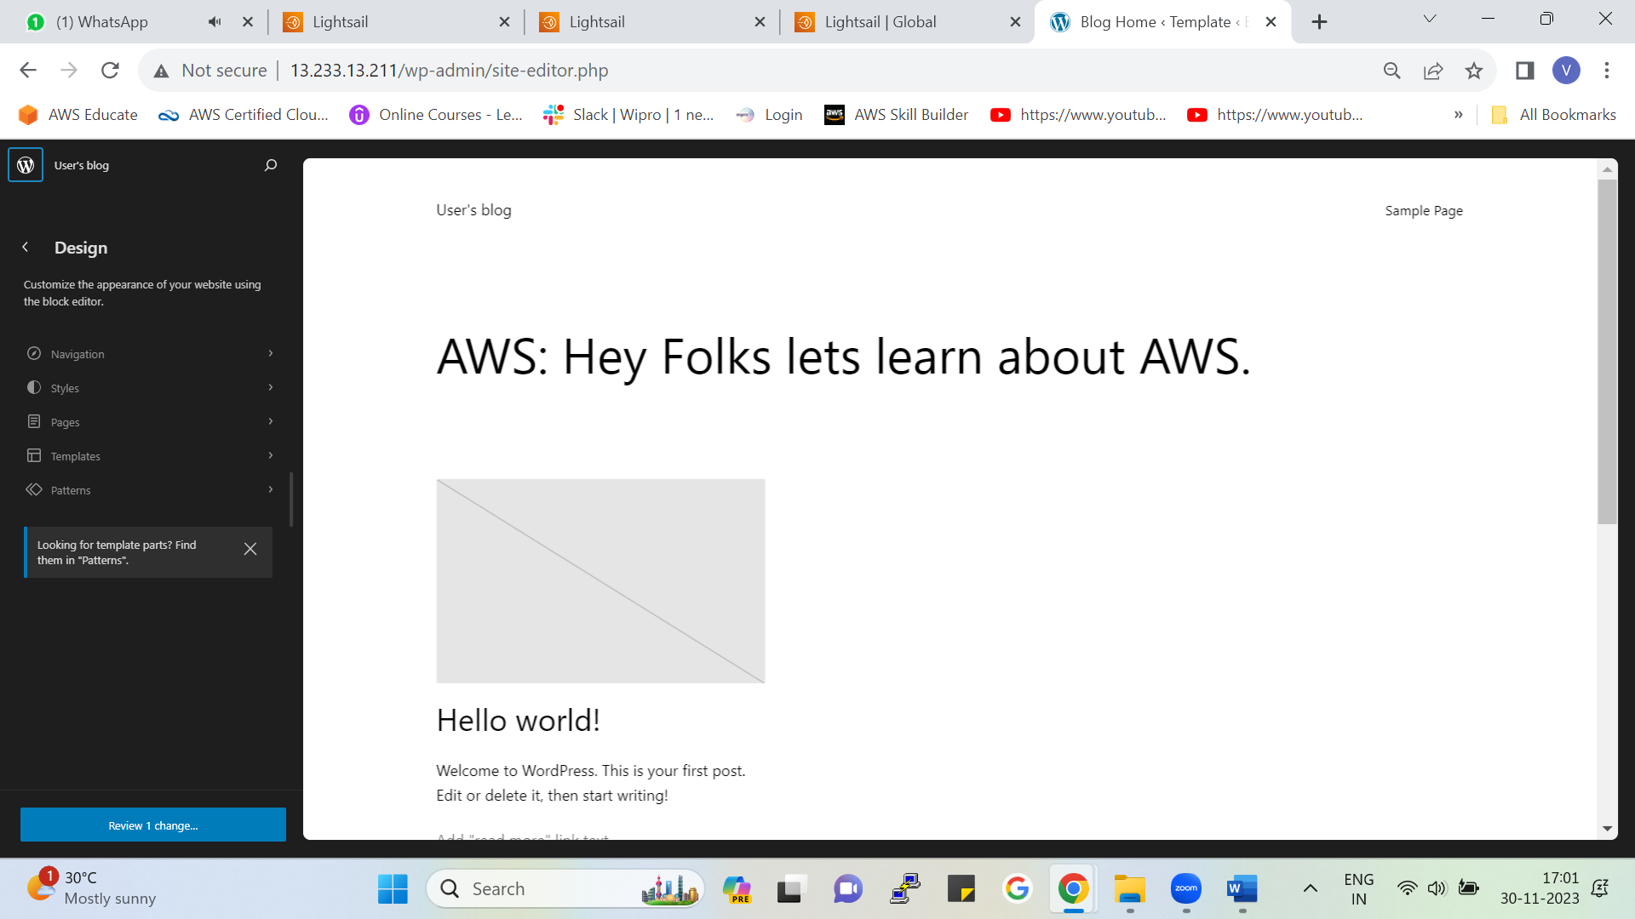

Here in WordPress (admin) you can create custom pages add styles to your pages in a stylish way

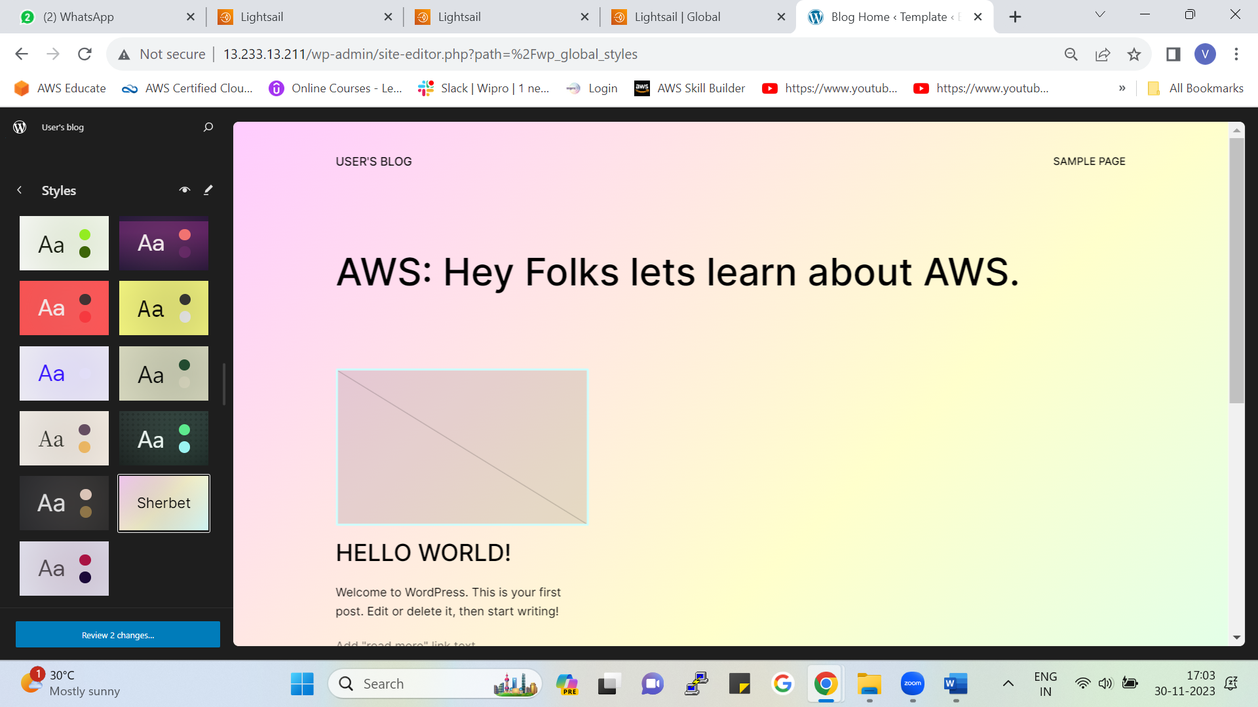

As you can see in WordPress (admin) we can add new styles for our webpage

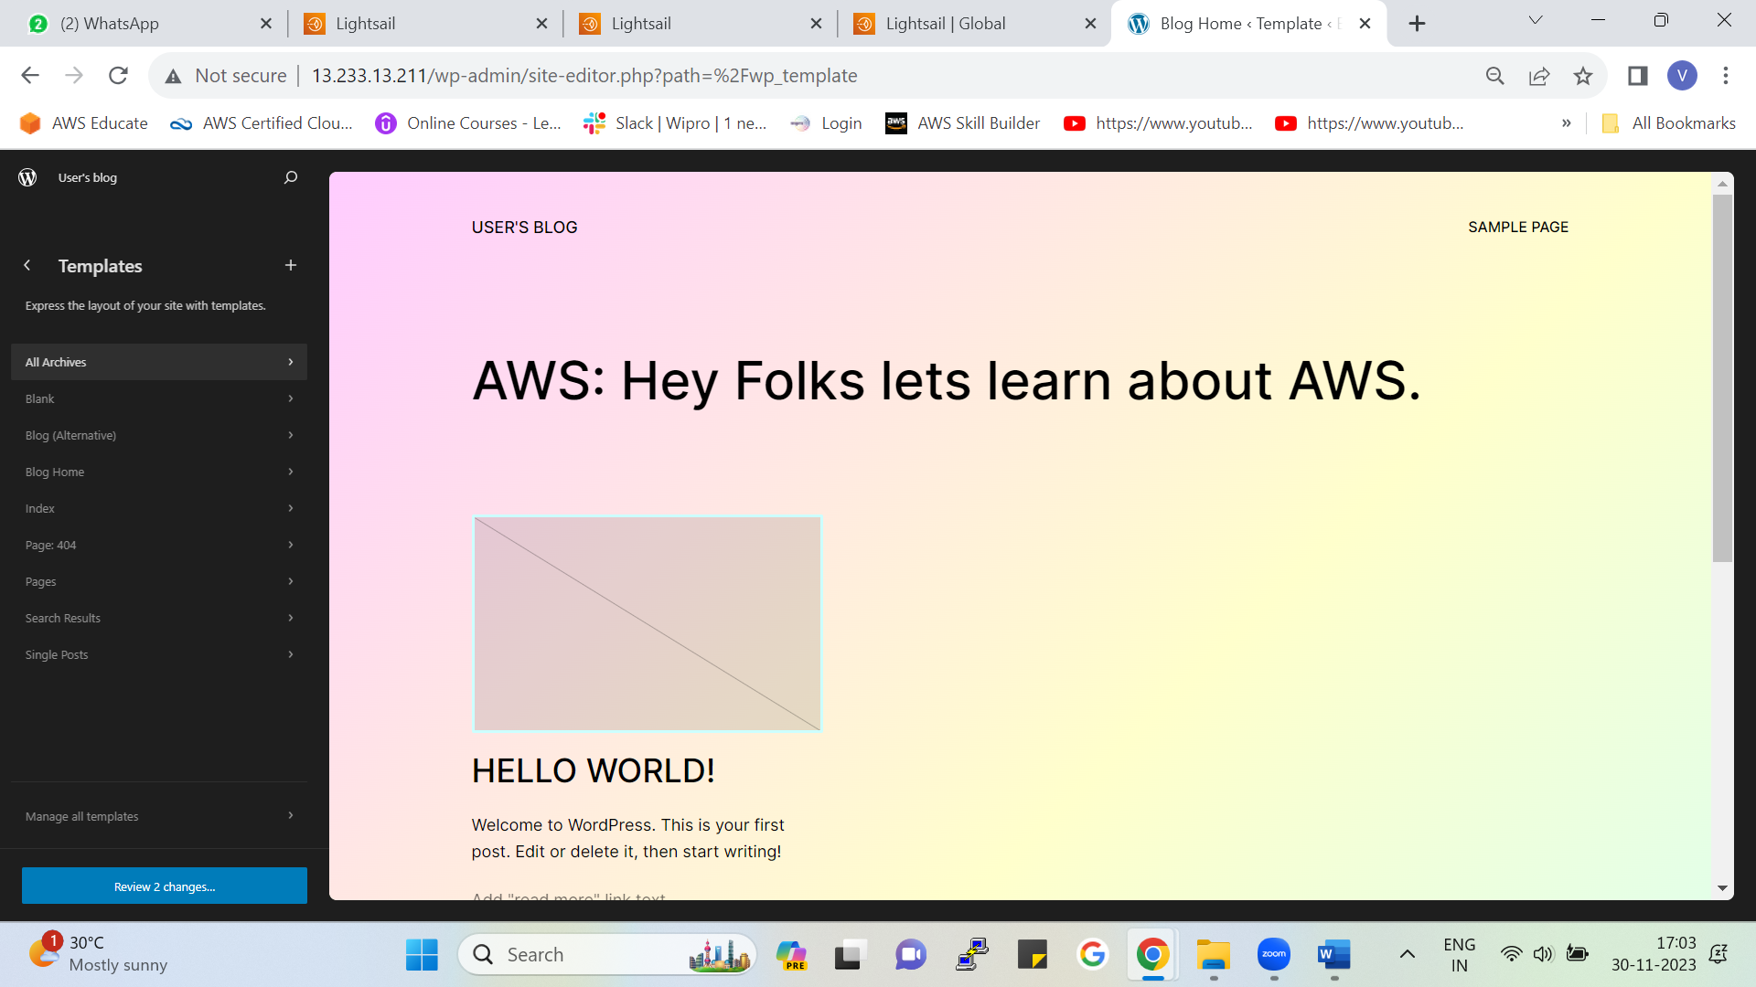

You will also get predefined templates over here we can customize these templates (e.g. Blank page, Blog page, Index page, 404 error page etc.)

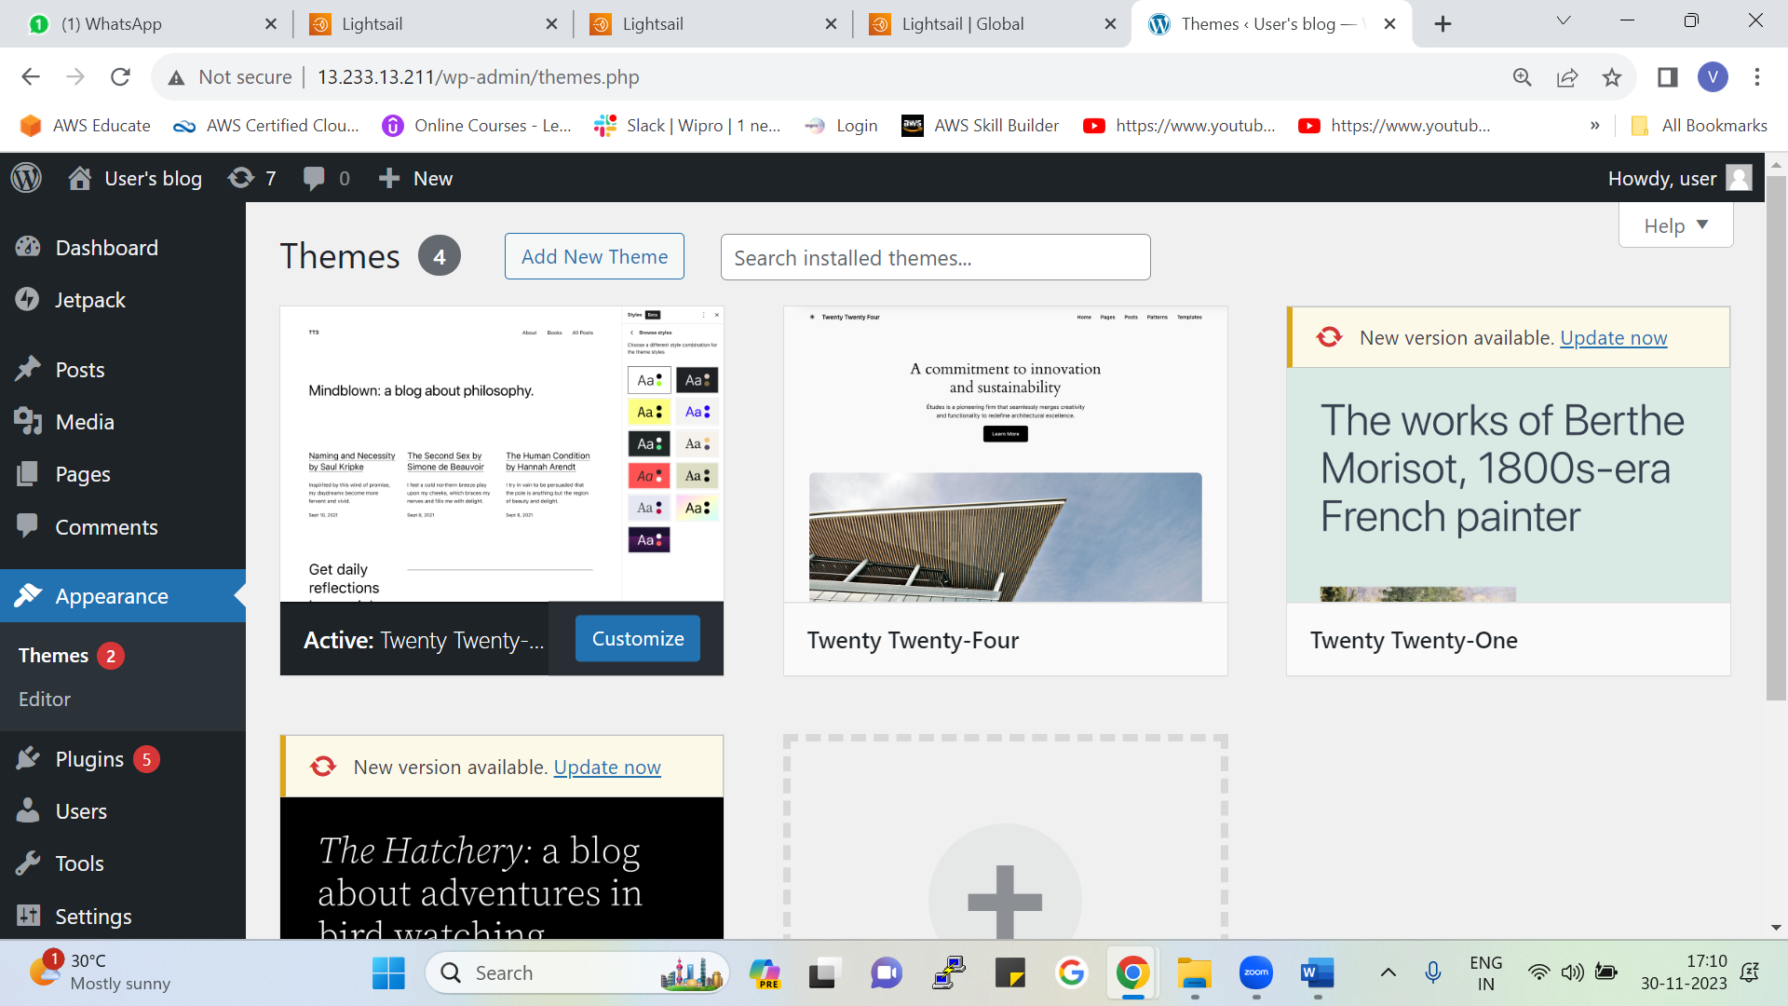

Coming on to homepage we can also change appearances of the webpage.

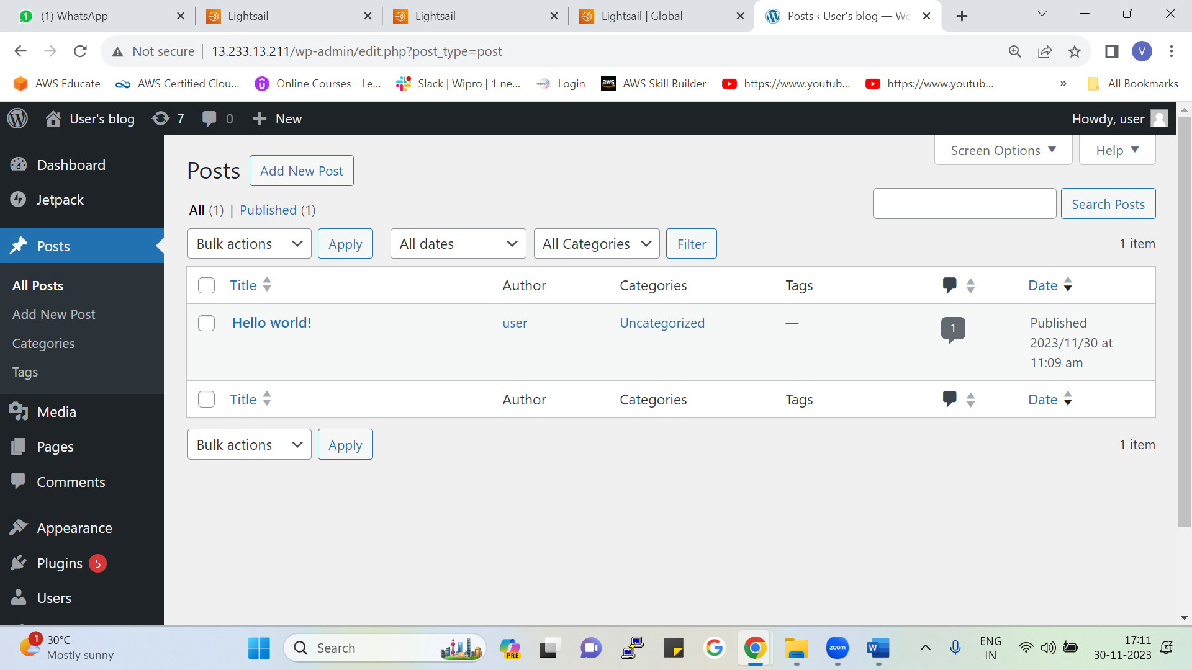

From here we can see our previous and currents posts we have created and can also customise them.

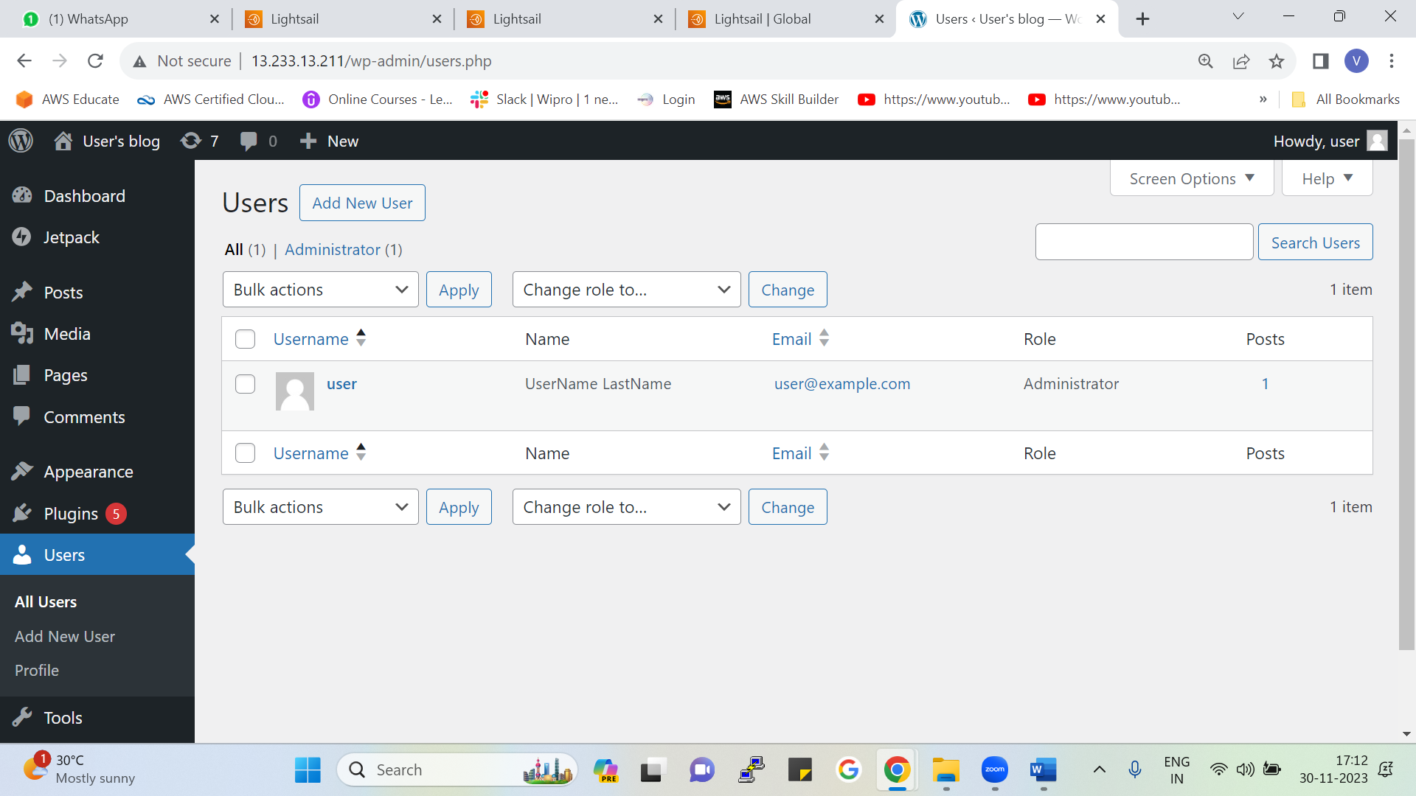

Here we will get the list of users who had logged in to the WordPress (Admin)

## Explore other services of the Console in Amazon Lightsail

Now Come back to the Lightsail Console.

Coming out of instance following services can also be added as per the requirement.

**Database**

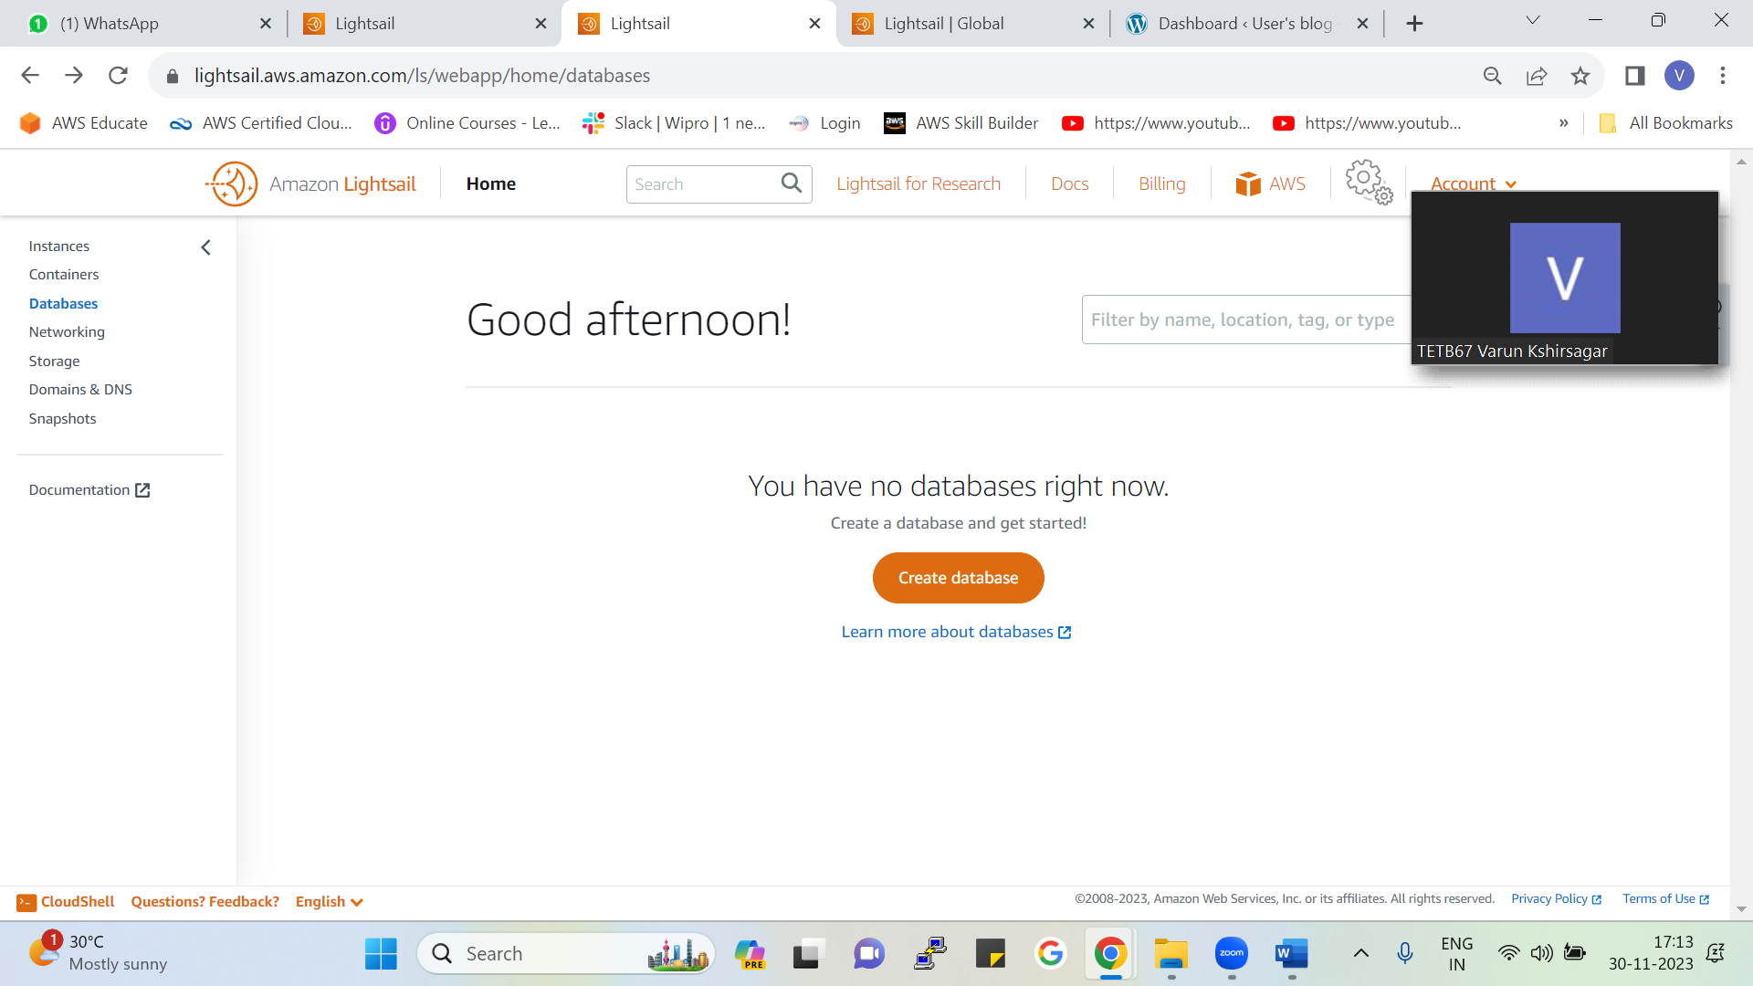

You can create new database from here

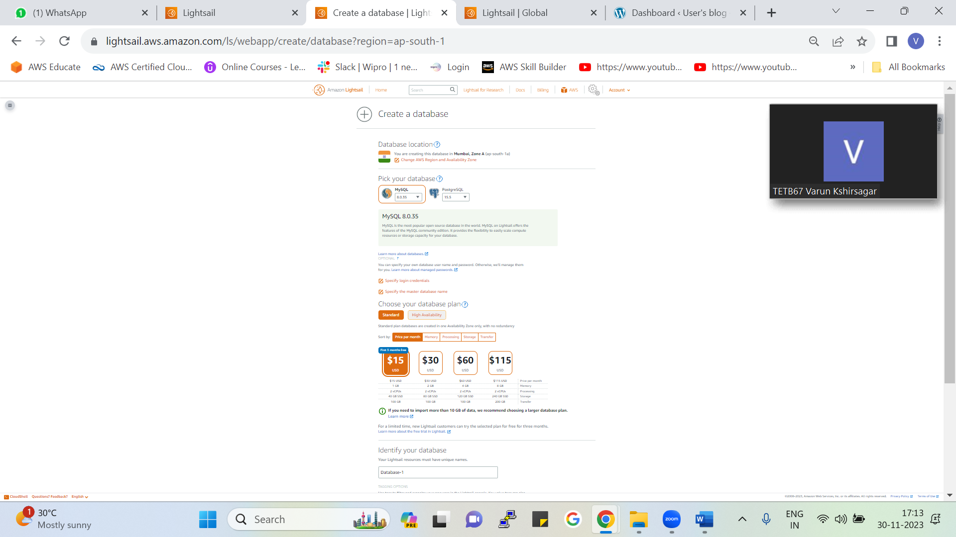

* After clicking on create new database following page will appear
* In this you need to select Region/AZ, choose database type, specify the DB plan, choose pricing , give name to your database, and click on create.

**NOTE:**

**Database Plans and their pricing**

1. **Standard**

Standard plan DB are created in only 1AZ so it has low availability and the price will be low

1. **High Availability**

High Availability DB are created in 3AZ so it has high availability and the prices will be comparatively higher.

**Storage**

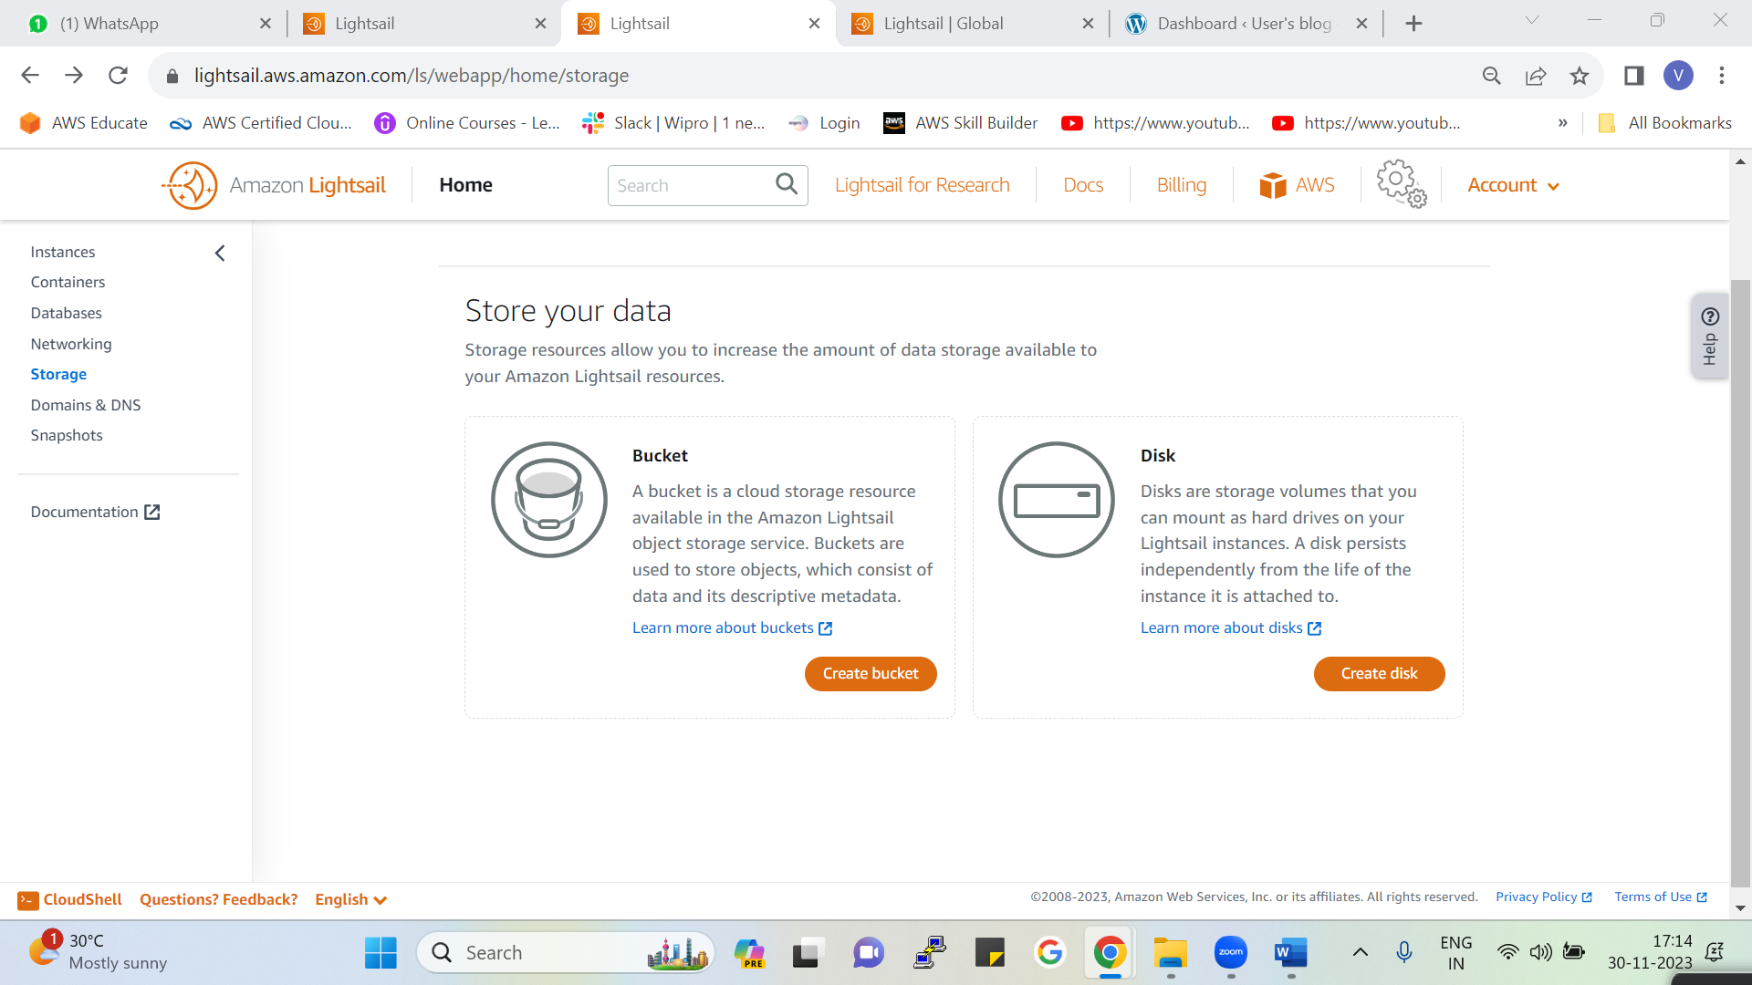

In storage we have two types (Bucket and Disk) from here we can add new bucket or new disk to our instance

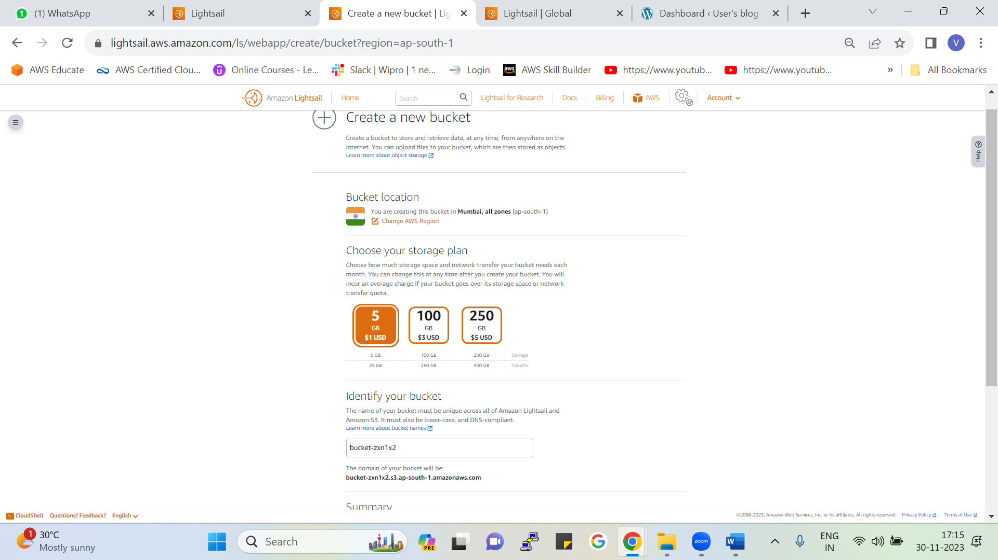

To add new bucket to your Instance, select the region/AZ , give name for your bucket, choose pricing depending upon the storage and click on create.

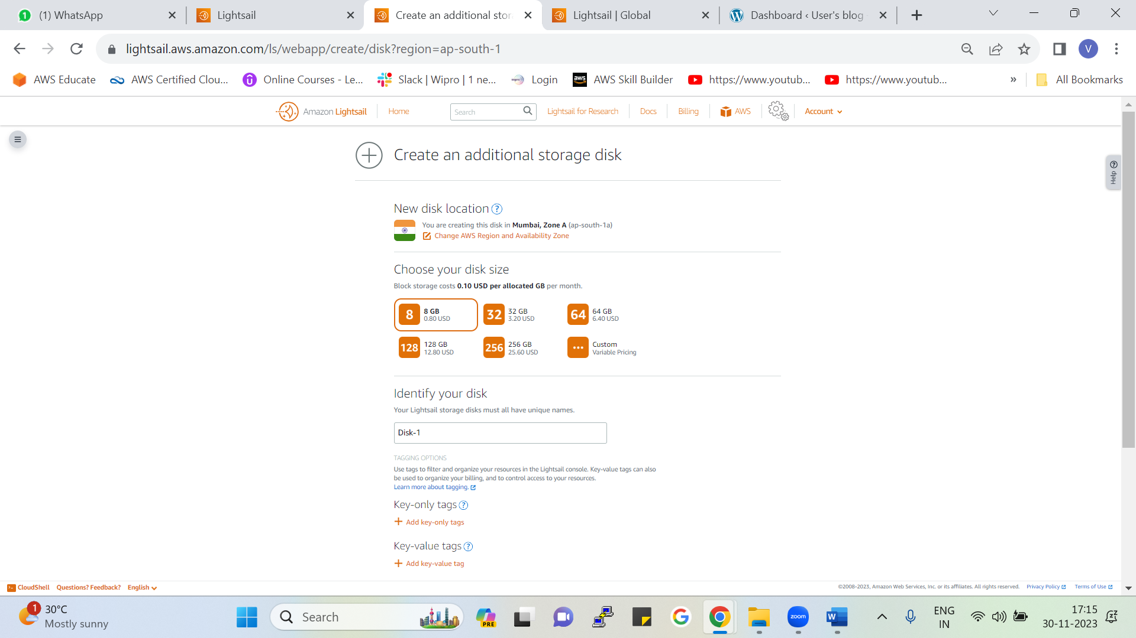

To add new disk to your Instance, select the region/AZ , give name for your disk, choose pricing depending upon the storage and click on create

**Domains and DNS**

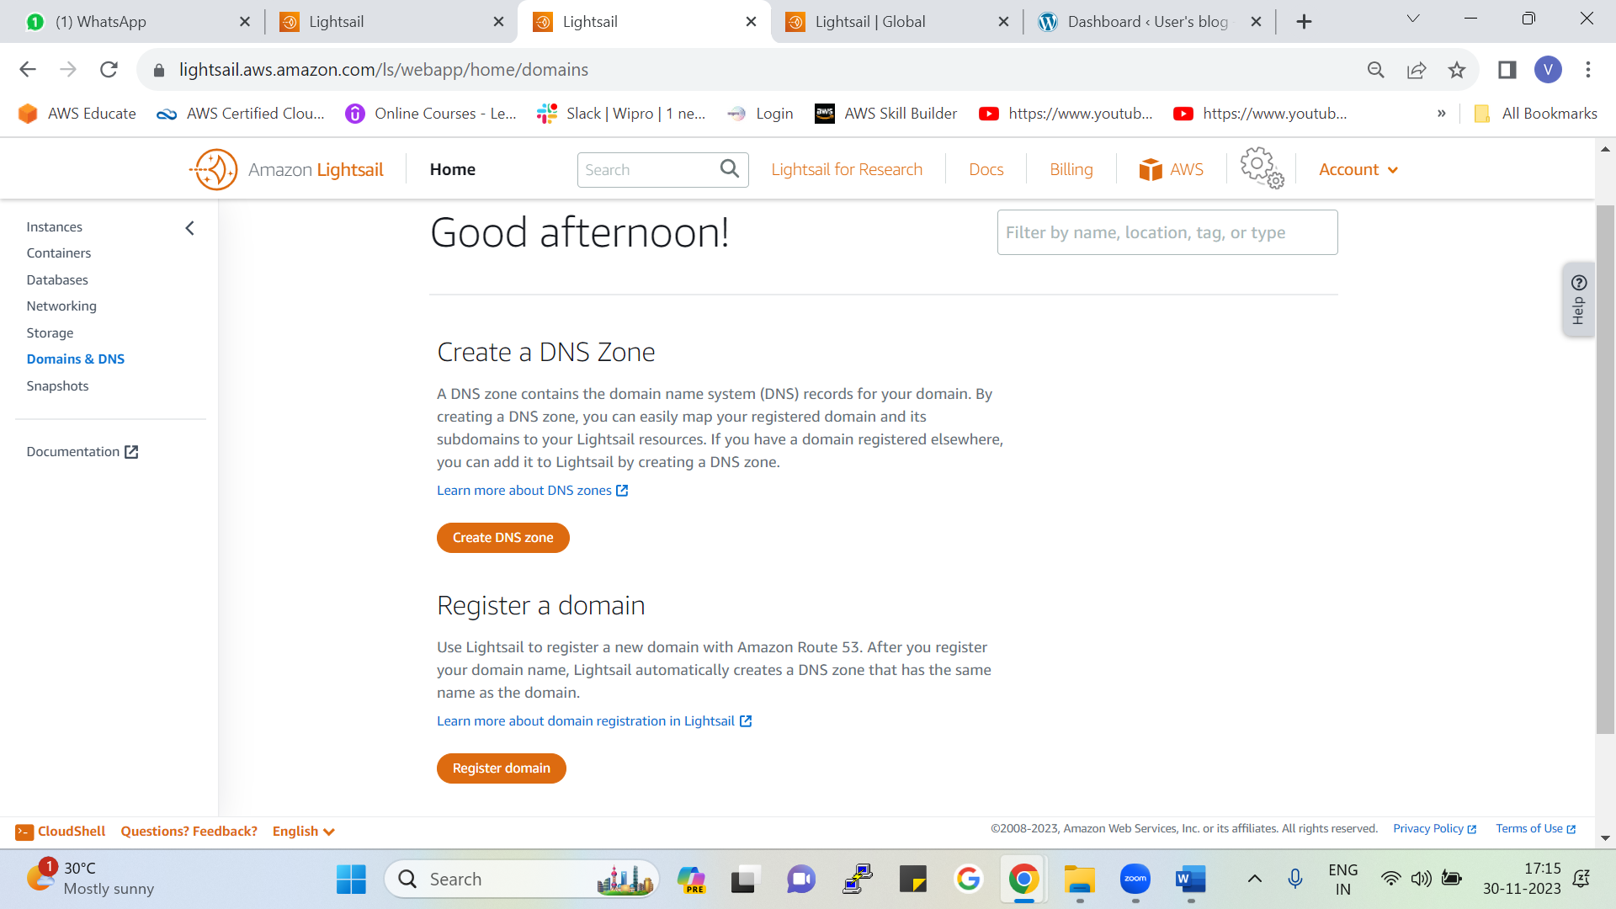

* In Domains and DNS, you can register a domain using route53 service as shown earlier
* Or can also create DNS Zone (All domains can be added over here even if they are registered elsewhere so that we can easily map [find them]).

**Snapshots**

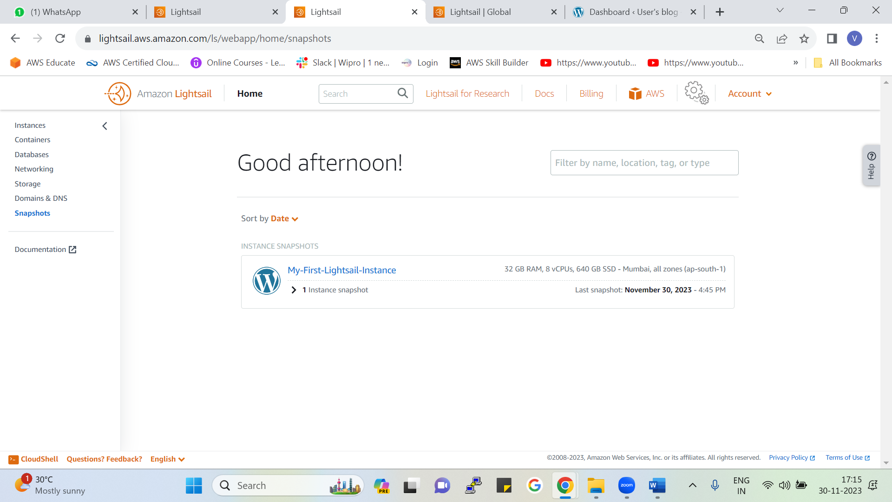

As in the earlier process we have seen that we had created manual snapshot of our instance so as shown in the following fig our snapshot is ready

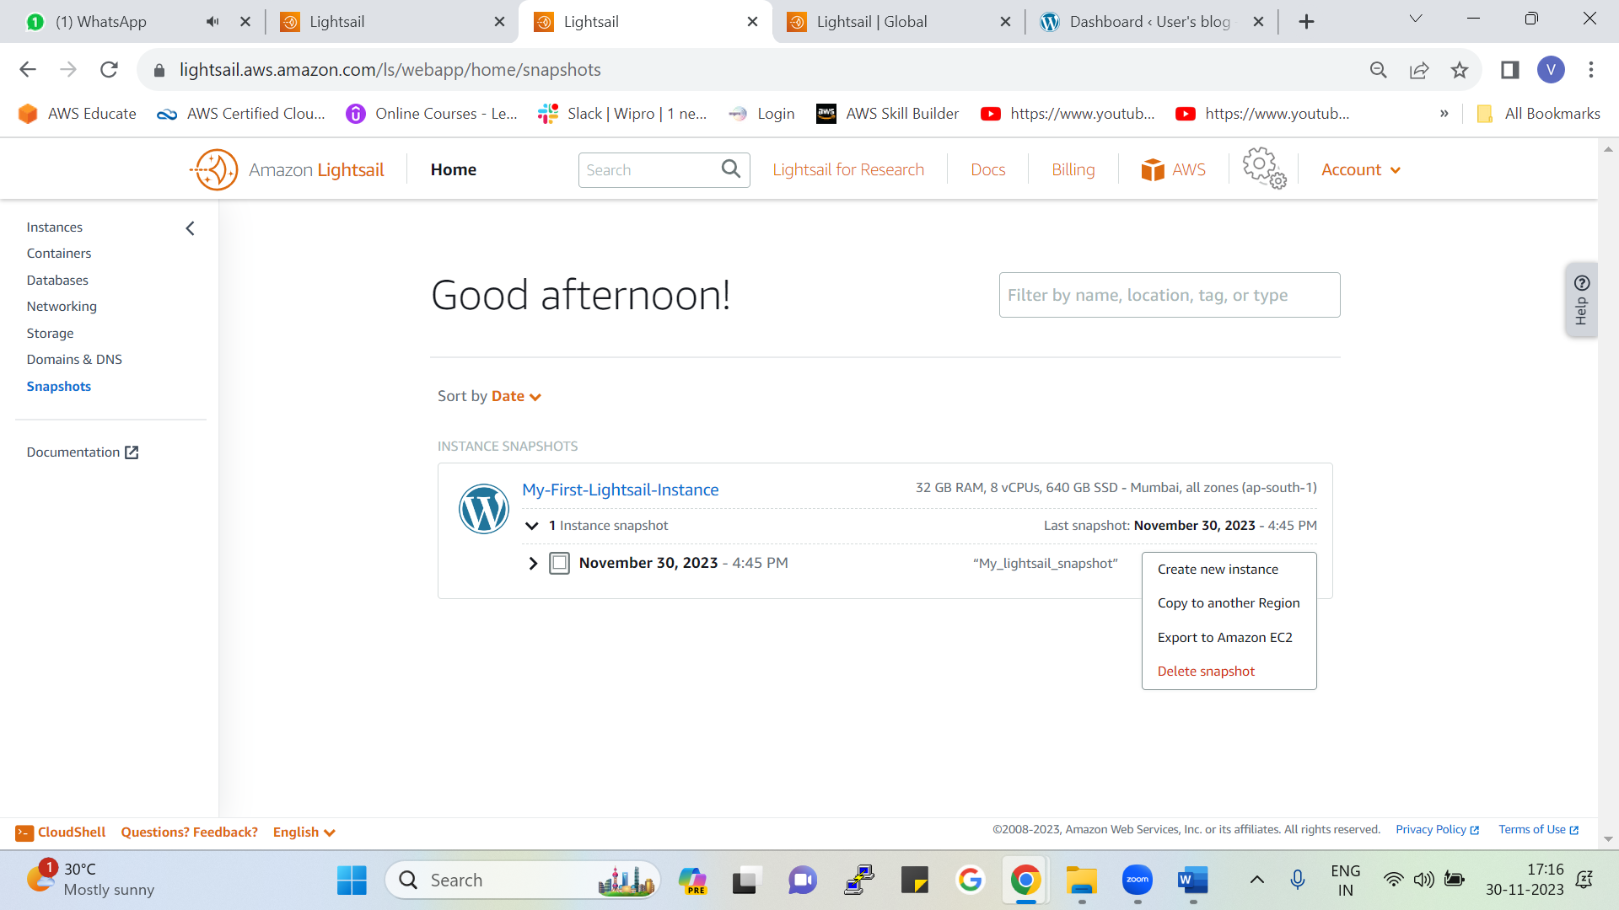

Here we can also see the date and time at which snapshot was created and can also find when the last snapshot was created.

By creating snapshot on the snapshot following operations can be performed.

1. Create new instance
2. Copy to another region
3. Export to amazon EC2
4. Delete snapshot

## Crete an instance from Snapshot.

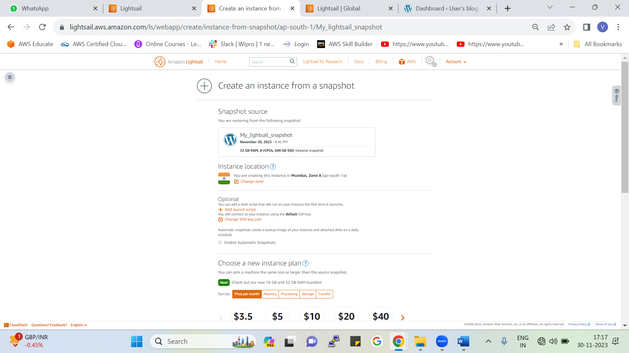

* Snapshot 🡪 Used for creating backup of volume
* If something happens to the older instance then with the help of snapshot we can create new instance from the snapshot

## Snapshot to Copy

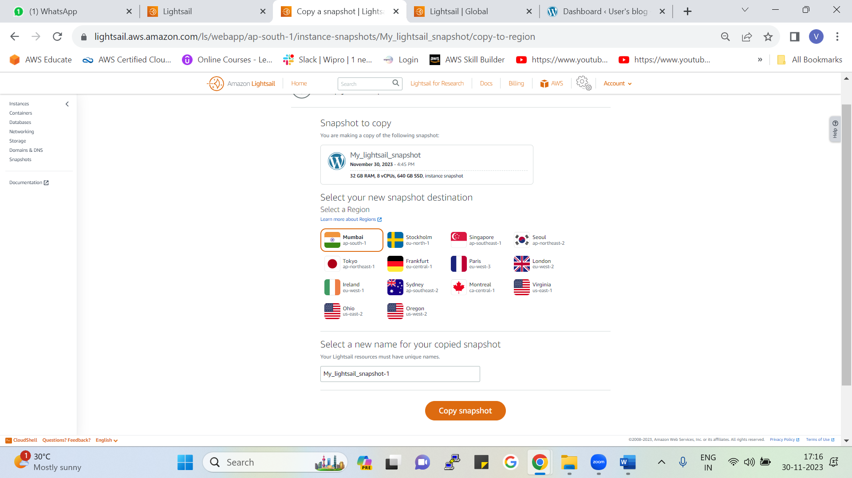

* If you want to create the copy of same instance into another region then we can create it by snapshot.
* By simply copying our snapshot from one region to another region (e.g., Mumbai🡪 N. Virginia) and then creating instance from that copied snapshot.

**To copy to another region**

Select the snapshot you want to copy 🡪 Select the region in which you want to copy 🡪 Give name for the new copied snapshot and click on copy snapshot

## Export snapshot to amazon EC2.

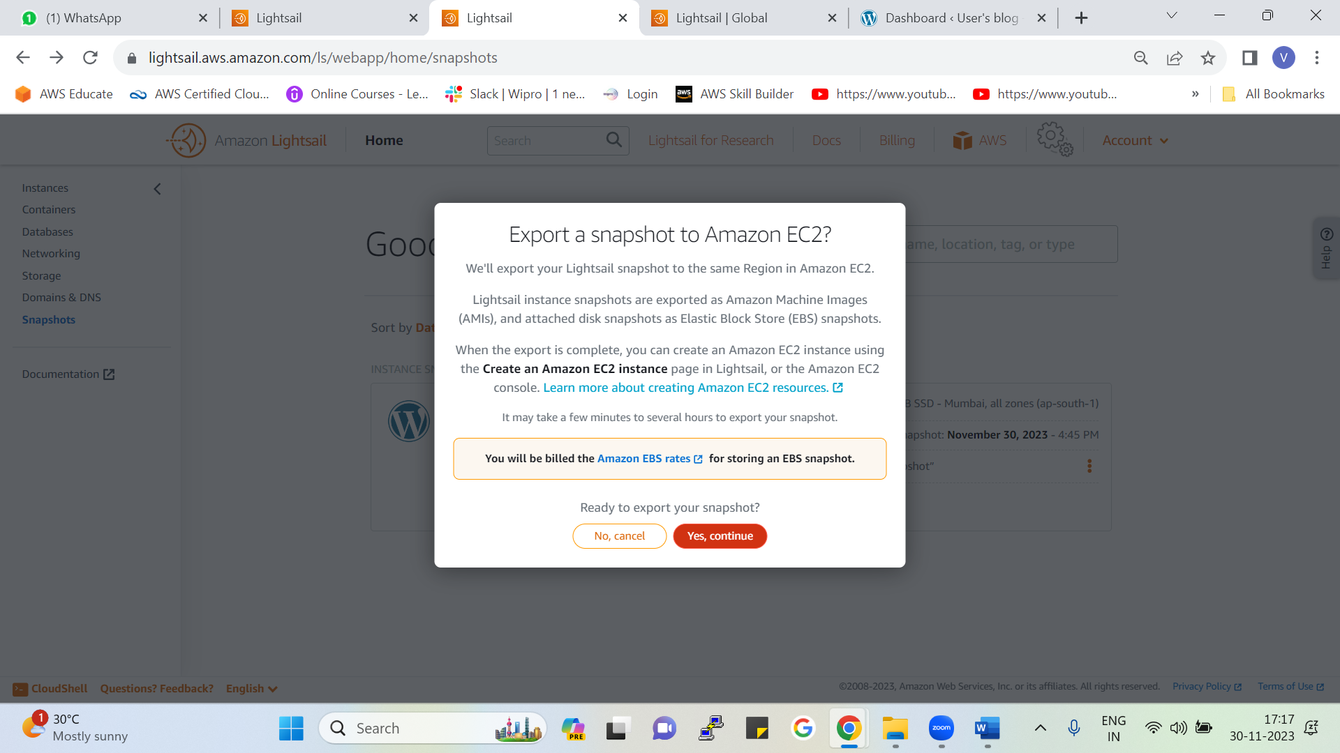

* You can export Amazon Lightsail instance and block storage disk snapshots to Amazon Elastic Compute Cloud (Amazon EC2).
* Exporting a Lightsail instance snapshot results in an Amazon Machine Image (AMI) and an Amazon Elastic Block Store (Amazon EBS) snapshot being created in Amazon EC2.
* From that AMI and EBS Volume you can create EC2 instance into your EC2 Console.